CONTINUING EDUCATION PROGRAM –

CENTER FOR COMPUTING AND INFORMATION TECHNOLOGY

FACULTY OF ENGINEERING

UNIVERSITY OF INDONESIA

**Project**

**DVD Online Shop**

**Name : Andika Saputra**

**Ugi Ispoyo Widodo**

**Faculty : Emma Yulianti, St. MM**

**Semester : 3**

**Quarter : 2**

**Class : 3SC4**

**Gedung Pascasarjana Lt. 3 Fakultas Teknik Universitas Indonesia**

**Kampus Baru UI Depok 16424**

**PROJECT ON**

*DVD Online Shop*

Developed By

Name : *Andika Saputra*

*Ugi Ispoyo Widodo*

Reg. No.:

NIIT

**DVD Online Shop**

Batch Code :

Start Date :  *November 30th, 2015*

End Date : *December 30th , 2015*

Name Of The Coordinator : *Mrs. Emma Yulianti, S.T, MM*

Name Of Developer : *Andika Saputra*

*Ugi Ispoyo Widodo*

Date Of Submission : *December 31st , 2015*

NIIT

**CERTIFICATE**

This is to certify that this report, titled ***DVD Online Shop*** embodies the original work done by ***Andika Saputra*** *and* ***Ugi Ispoyo Widodo*** in partial fulfillment of their course Requirement at NIIT.

Coordinator: ***Mrs. Emma Yulianti, S.T, MM***

**ACKNOWLEDGEMENT**

The Project presentation opportunity we have with CCIT-FTUI is a great change for learning and professional development. Therefore, we consider ourselves very lucky as we are provided with an opportunity to be a part of it. We are also grateful for having a change to meet so many wonderful people and professionals who led us through this project period.

Bearing in mind, we would like to express our deepest gratitude and special thanks to Mrs. Emma Yulianti, S.T, MM of CCIT-FTUI faculty who is spite of being extraordinarily busy with his duties, took time out to hear, guide and keep us on the correct path and allowing us to carry out our project until completion.

Our project assignment won’t be as good as it is now without any help, feedback and suggestion that were given to us by our friends within the campus. So, we would also like to say thank you to all of them. We will strive to use grained skills and knowledge in the best possible way, and we will continues to work on the improvements, in order to attain desired career objective.

**SYSTEM ANALYSIS**

**System Summary :** DOS (DVD Online Shop) is a web application that provides a simple way for Customer to order DVD online.

The Proposed web application for DVD Online Shop will be used by three different types of users :

* Customers
* Servant
* Administrator

The proposed web application needs to provide the following functionalities to a customer:

* Registration
* Login and logout
* Place an order
* View Order
* Modify Personal Info
* Cancel Order

The proposed web application needs to provide the following functionalities to a servant:

* Login and logout
* View Customer Order
* Check Payment Order
* Change Order Status
* View Customer Data
* View DVD Data
* Print Receipt

The proposed web application needs to provide the following functionalities to an administrator:

* Login and logout
* Search, add, update, delete DVD data and employee data
* Monitoring customer order and customer data
* Print customer data, employee data, print order data.

**HARDWARE AND SOFTWARE REQUIREMENTS**

**Hardware :**

Intel® Core ™ i3-4005U CPU @1.70Ghz 1.70 Ghz 32bit

Installed Memory (RAM) 2Gb

Hard Drive 500GB

**Operating System :** Windows 7 Ultimate

**Software :**

* Astah Community
* Microsoft Word 2010
* Microsoft Power Point 2010

**INDIVIDUAL PROJECT SCHEDULE**

|  |  |  |  |  |  |
| --- | --- | --- | --- | --- | --- |
| ***S.No*** | ***Activity Description*** | ***Planned Of Completion*** | ***Actual Date*** | ***Responsibility*** | ***Remarks*** |
| *1.* | *Analyze the case study* | *7th*  *December 2015* | *7th*  *December*  *2015* | *Andika Saputra* |  |
| *2.* | *Create the Use Case diagram* | *8th*  *December 2015* | *10th*  *December 2015* | *Andika Saputra* |  |
| *3.* | *Create the Class diagram* | *12th*  *December 2015* | *14th*  *December 2015* | *Ugi IspoyoWidodo* |  |
| *4.* | *Crate the Sequence diagram* | *15th*  *October 2015* | *16th*  *December 2015* | *Ugi Ispoyo Widodo* |  |
| *5.* | *Create the Activity diagram* | *17th*  *December 2015* | *20th*  *December 2015* | *Andika Saputra* |  |
| *6.* | *Create the State Chart diagram* | *22th*  *December 2015* | *23th*  *December 2015* | *Ugi Ispoyo Widodo* |  |
| *7.* | *Create the Deployment diagram* | *23th*  *December 2015* | *24th*  *December 2015* | *Ugi Ispoyo Widodo* |  |
| *8.* | *Create the Component diagram* | *24th*  *December 2015* | *25th*  *December 2015* | *Ugi Ispoyo Widodo* |  |
| *9.* | *Create the Package diagram* | *26th*  *December 2015* | *27th*  *December 2015* | *Andika Saputra* |  |
| *10.* | *Create the Object diagram* | *27th*  *December 2015* | *27th*  *December 2015* | *Andika Saputra* |  |
| *11.* | *Create the Communication diagram* | *29th*  *December 2015* | *29th*  *December 2015* | *Andika Saputra & Ugi Ispoyo Widodo* |  |

**USE CASE DIAGRAM**

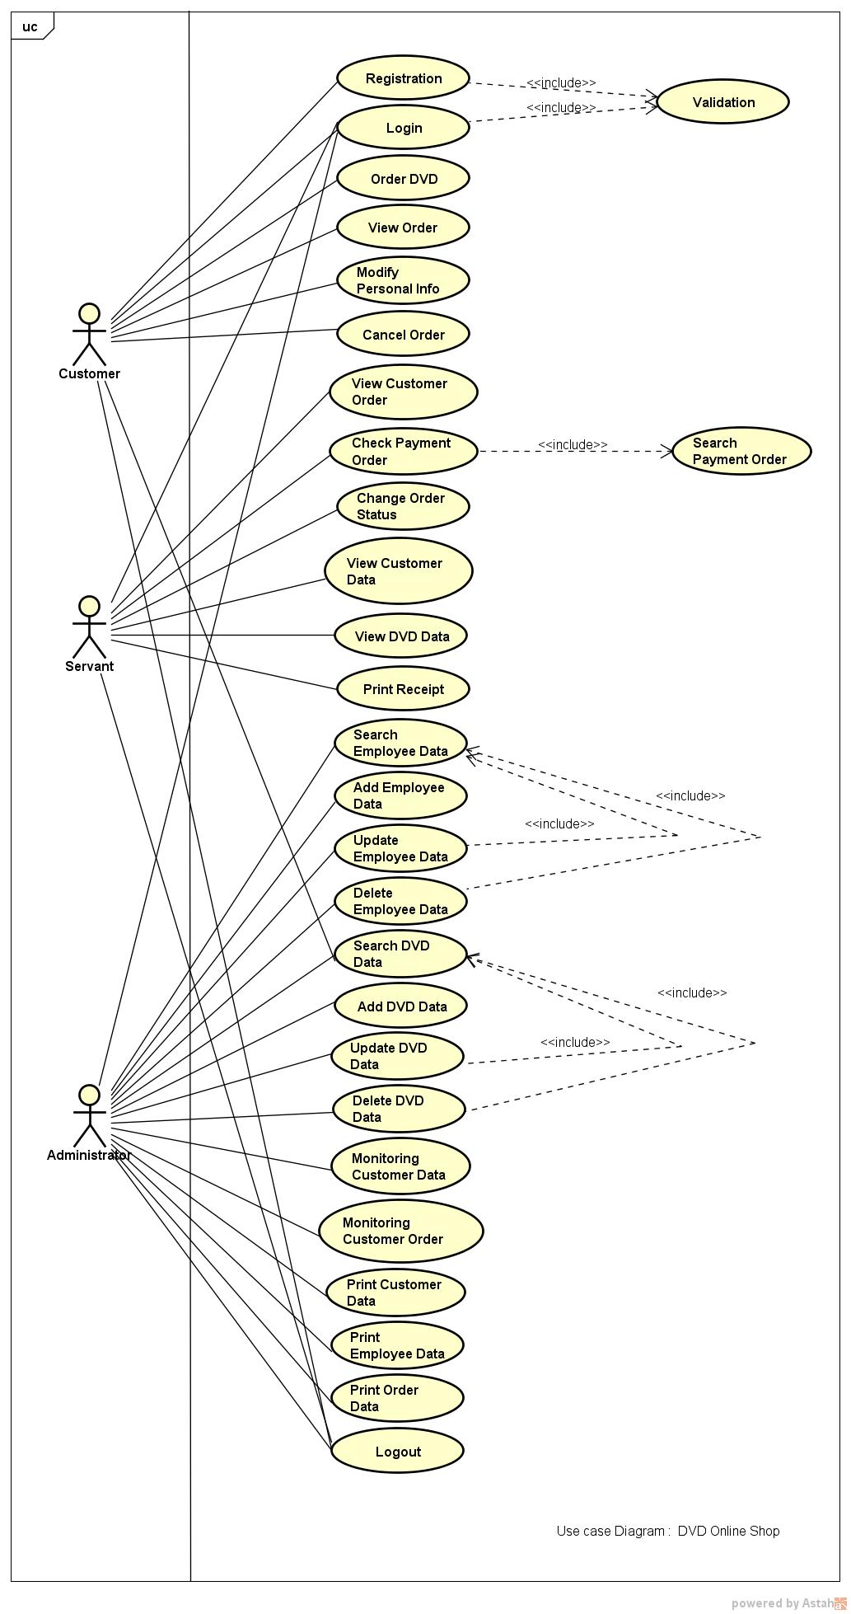

**CLASS DIAGRAM**

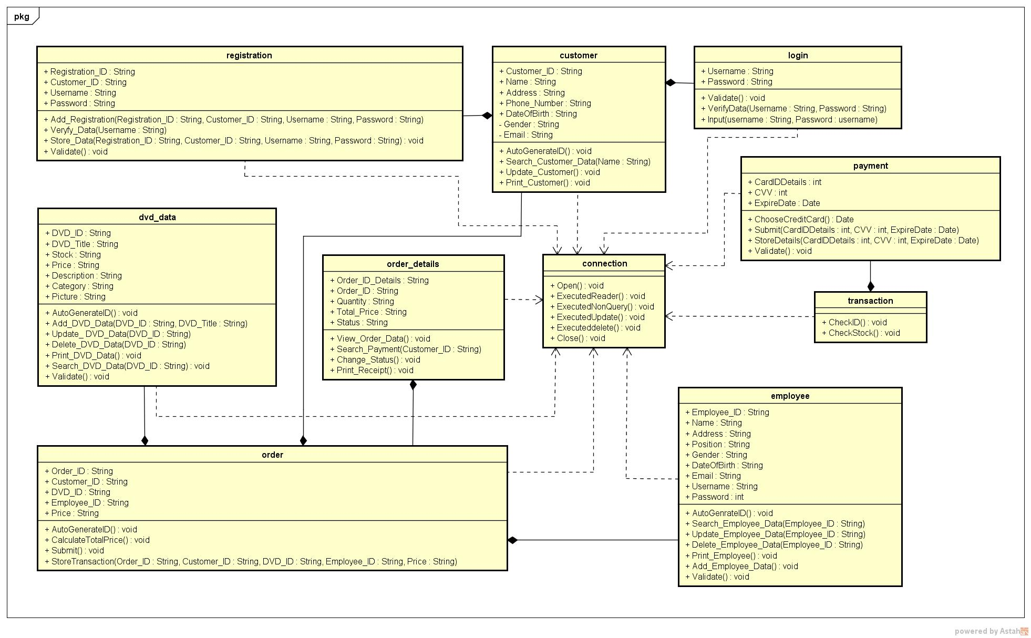

**SEQUENCE DIAGRAM FOR LOGIN**

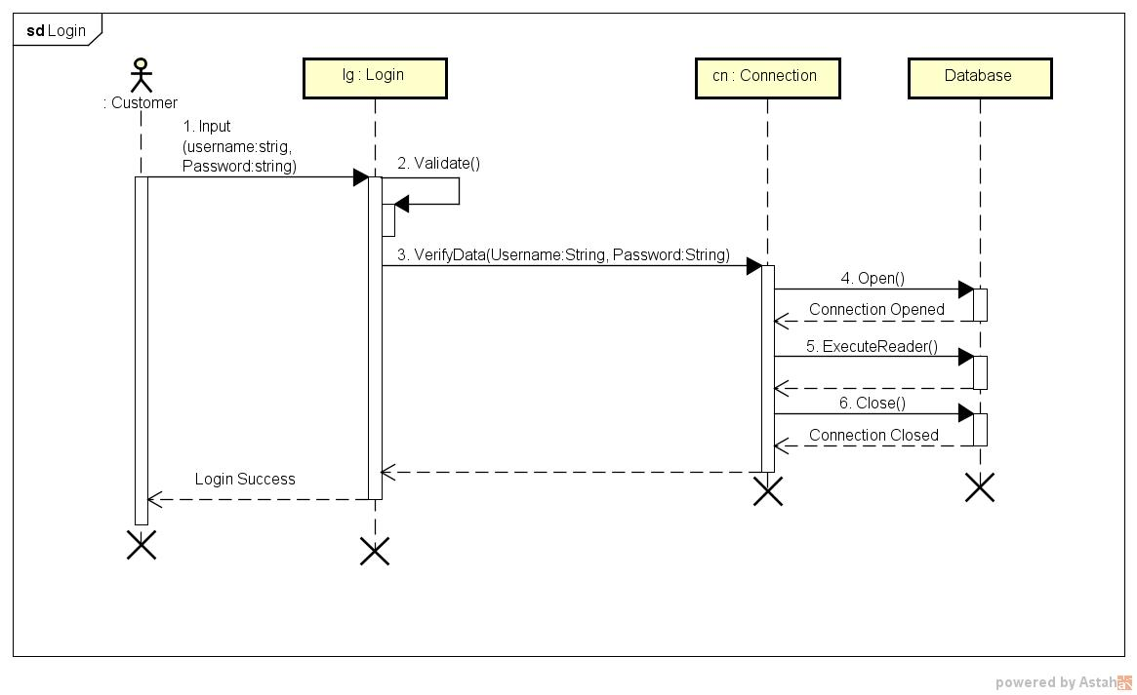

**SEQUENCE DIAGRAM FOR REGISTRATION**

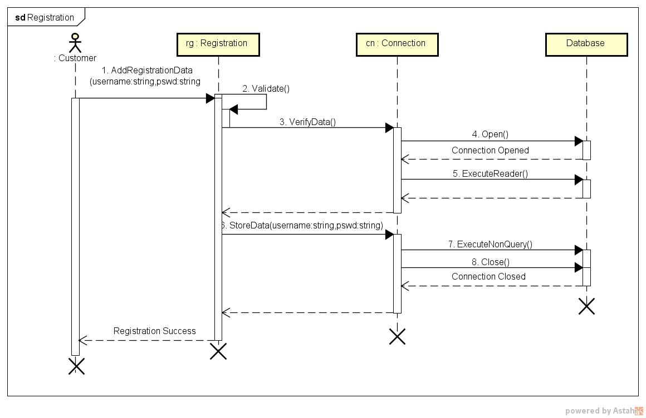

**SEQUENCE DIAGRAM FOR ORDER DVD**

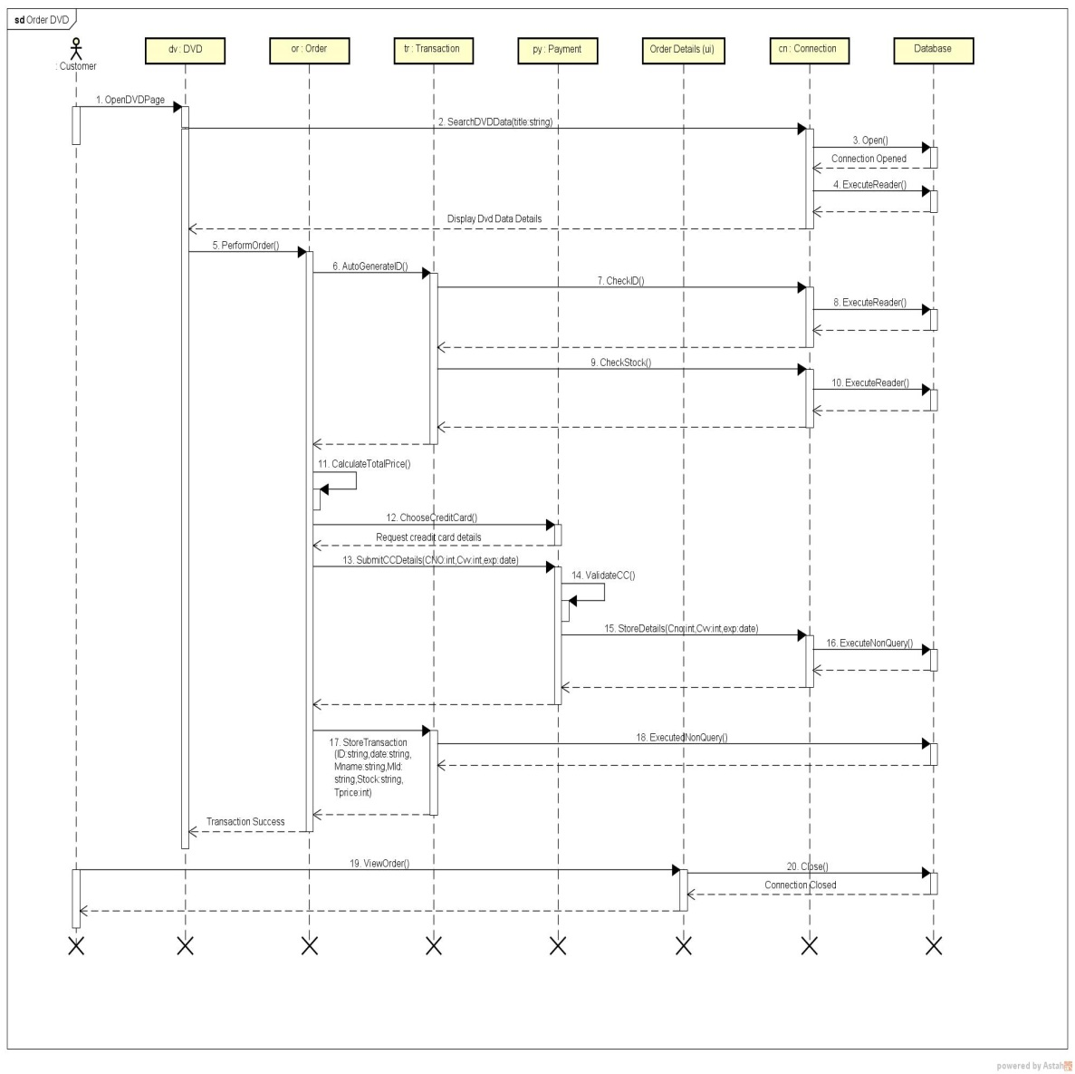

**SEQUENCE DIAGRAM FOR CHANGE ORDER STATUS**

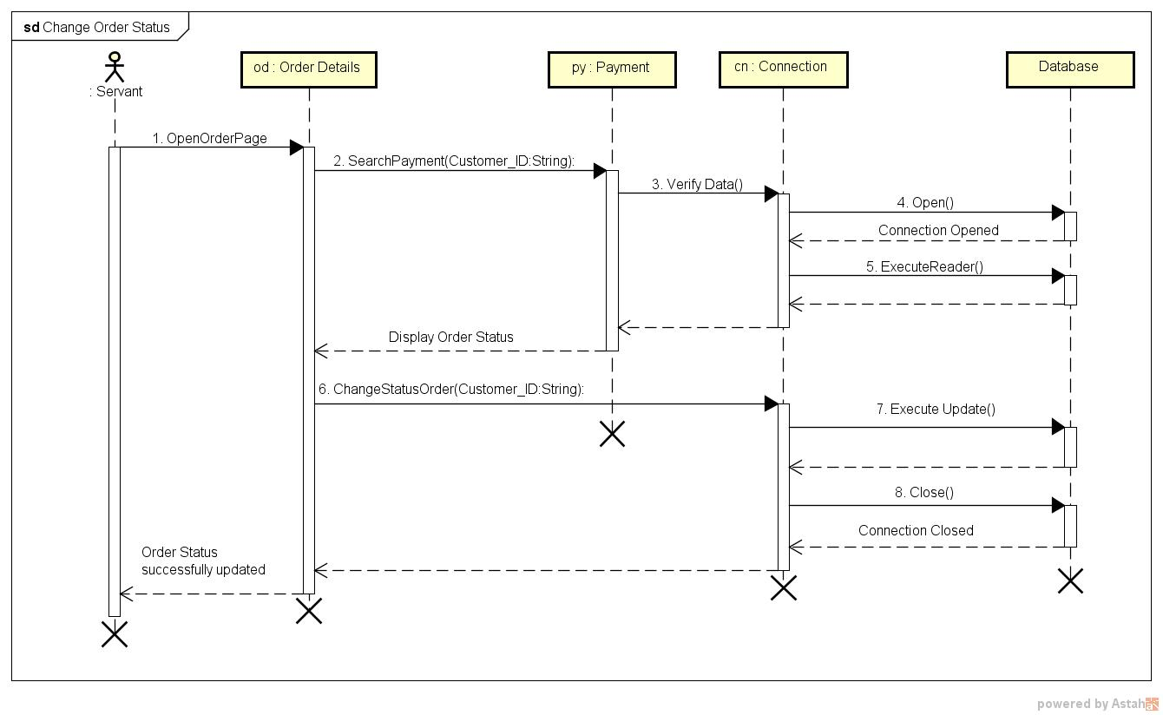

**SEQUENCE DIAGRAM FOR ADD DVD DATA**

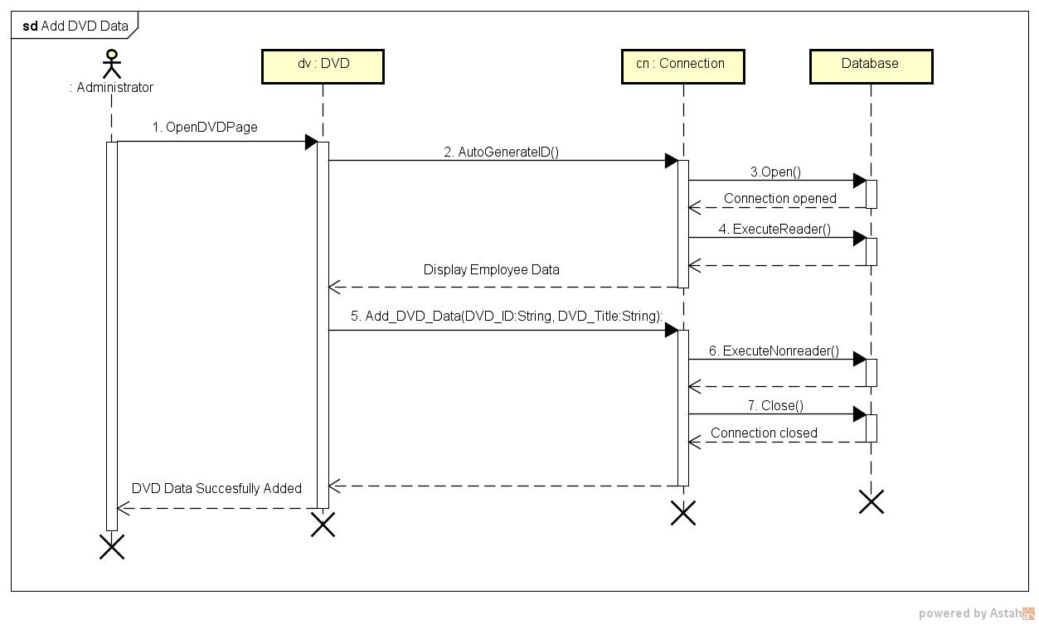

**SEQUENCE DIAGRAM FOR UPDATE DVD DATA**

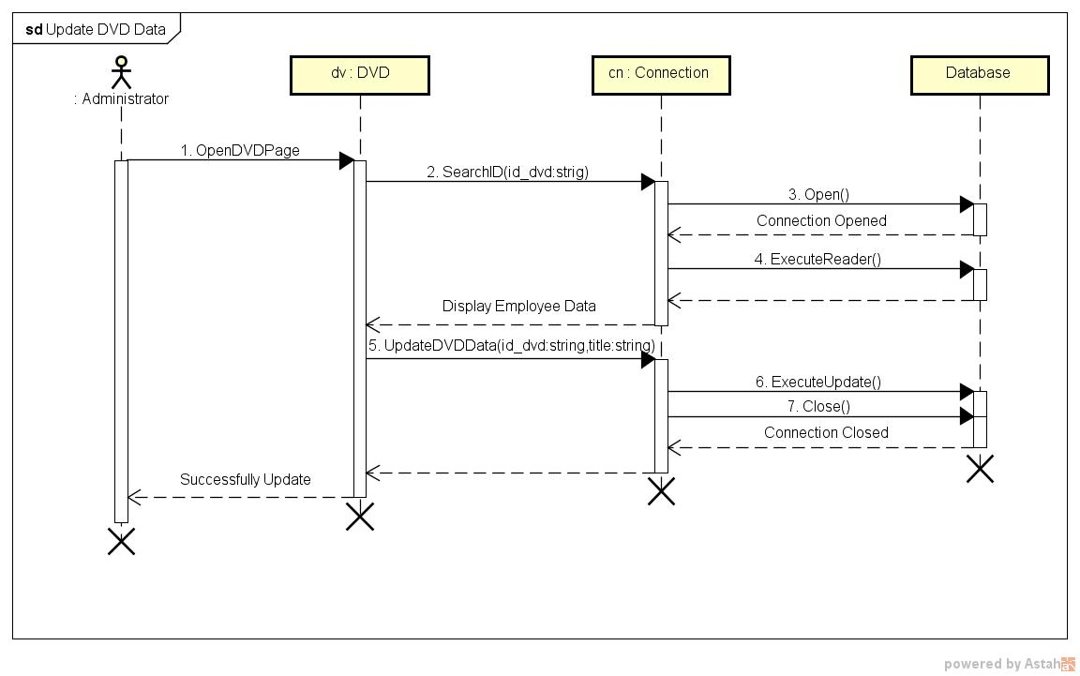

**SEQUENCE DIAGRAM FOR DELETE DVD DATA**

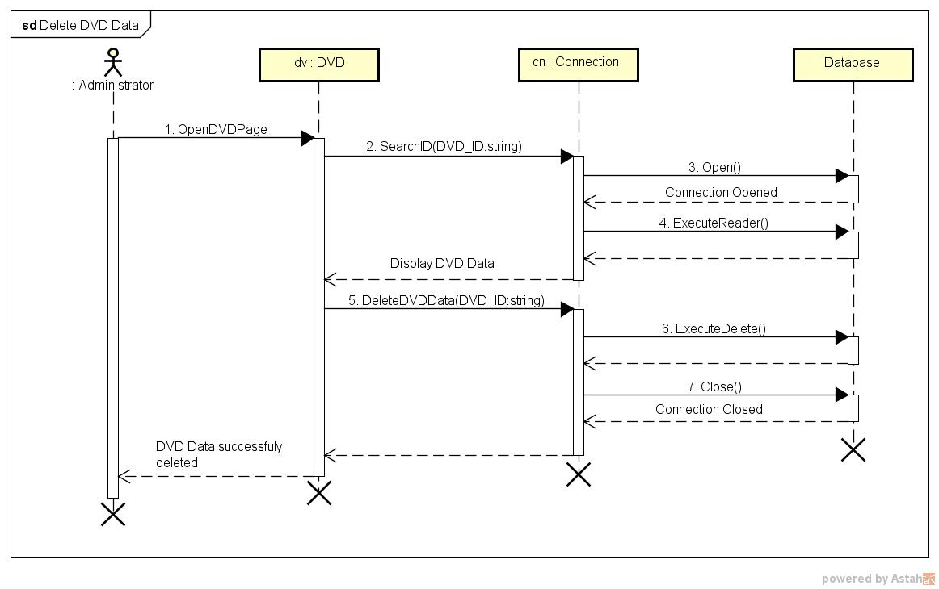

**SEQUENCE DIAGRAM FOR ADD EMPLOYEE DATA**

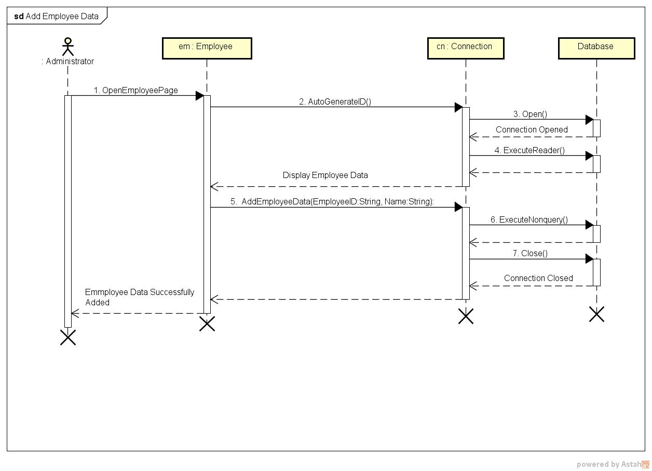

**SEQUENCE DIAGRAM FOR UPDATE EMPLOYEE DATA**

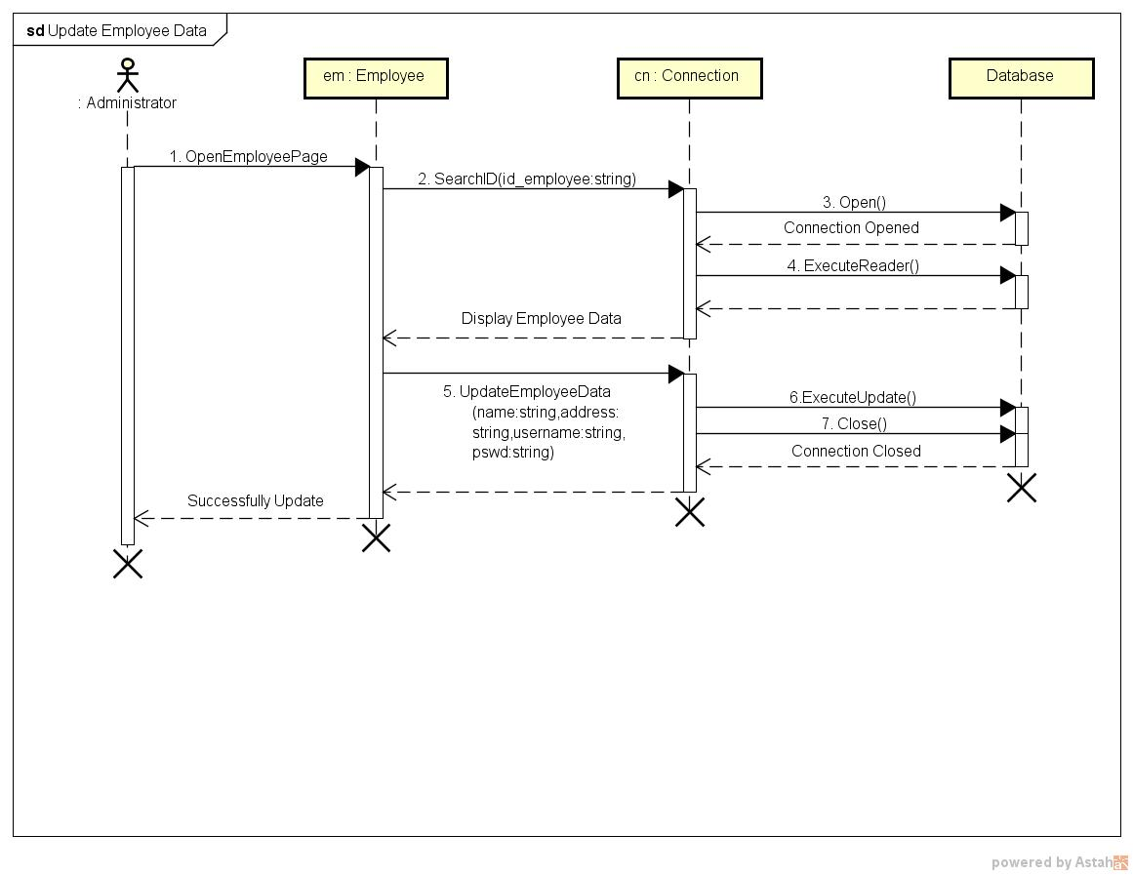

**SEQUENCE DIAGRAM FOR DELETE EMPLOYEE DATA**

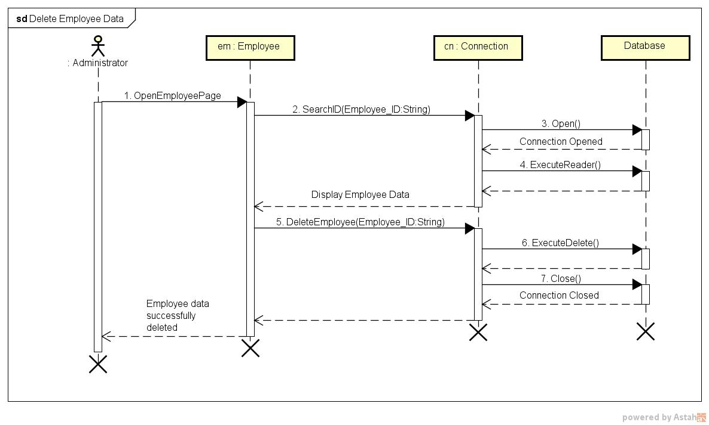

**SEQUENCE DIAGRAM FOR MODIFY PERSONAL INFO**

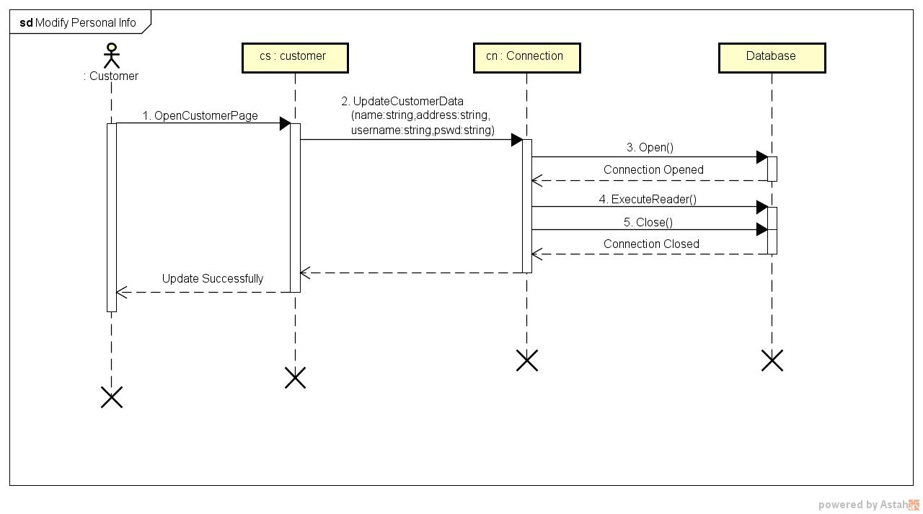

**COMMUNICATION DIAGRAM FOR LOGIN**

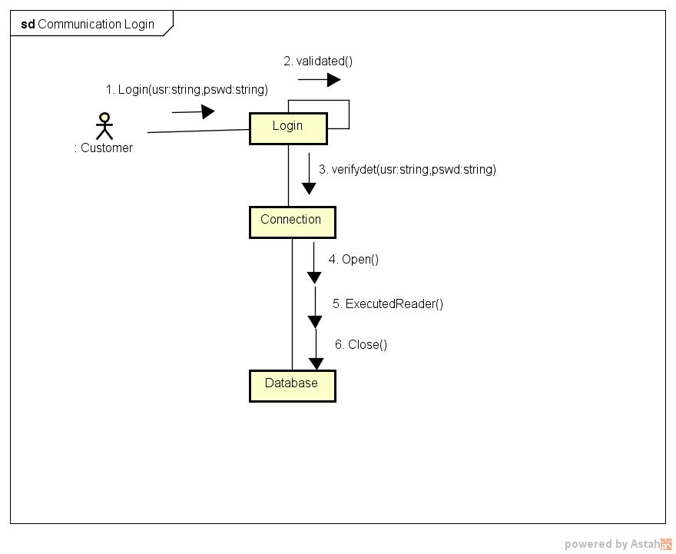

**COMMUNICATION DIAGRAM FOR REGISTRATION**

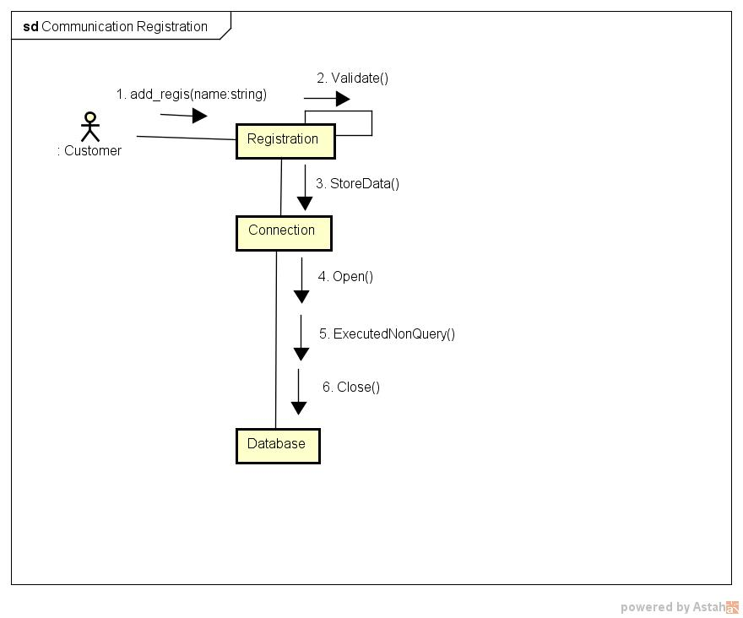

**COMMUNICATION DIAGRAM FOR ORDER DVD**

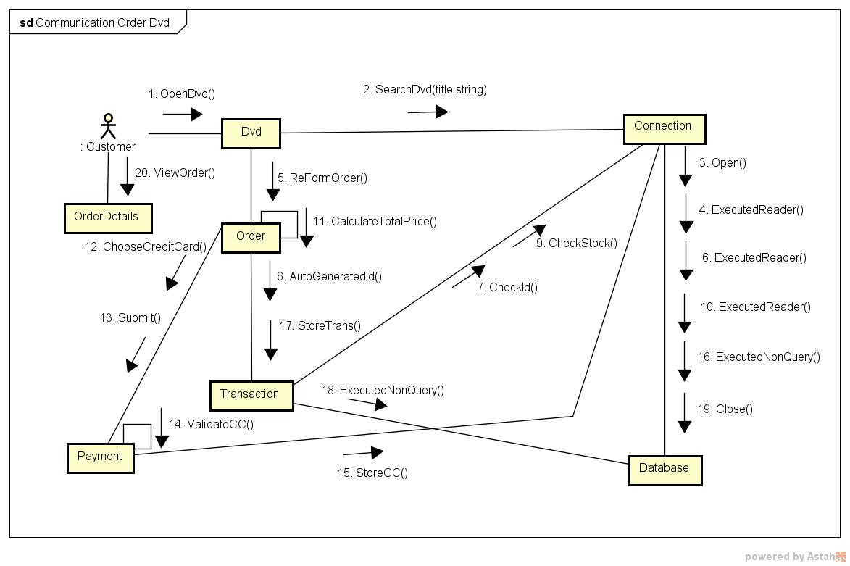

**COMMUNICATION DIAGRAM FOR CHANGE ORDER STATUS**

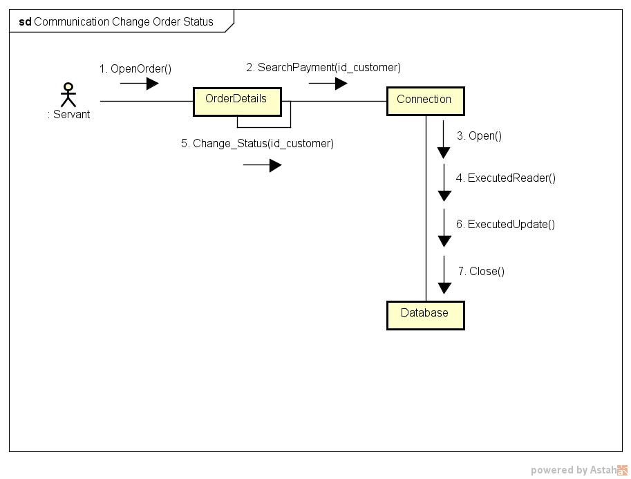

**COMMUNICATION DIAGRAM FOR MODIFY PERSONAL INFO**

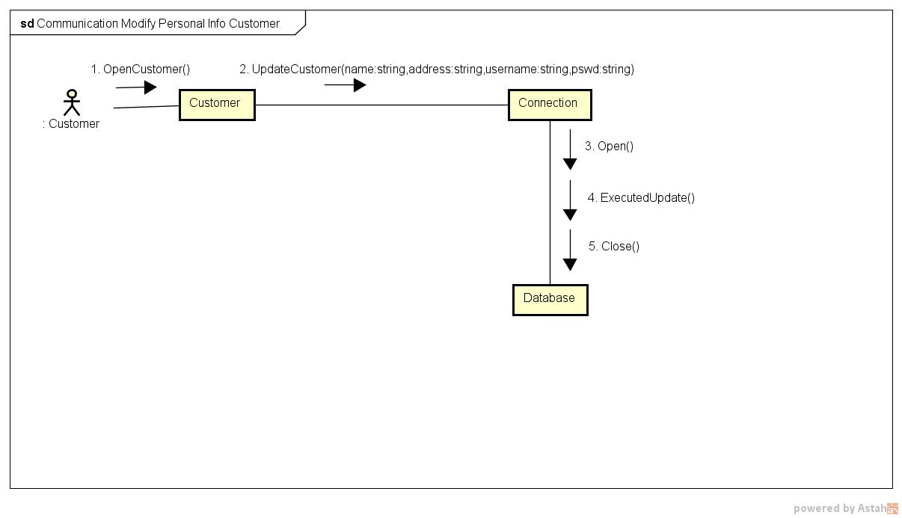

**COMMUNICATION DIAGRAM FOR ADD DVD DATA**

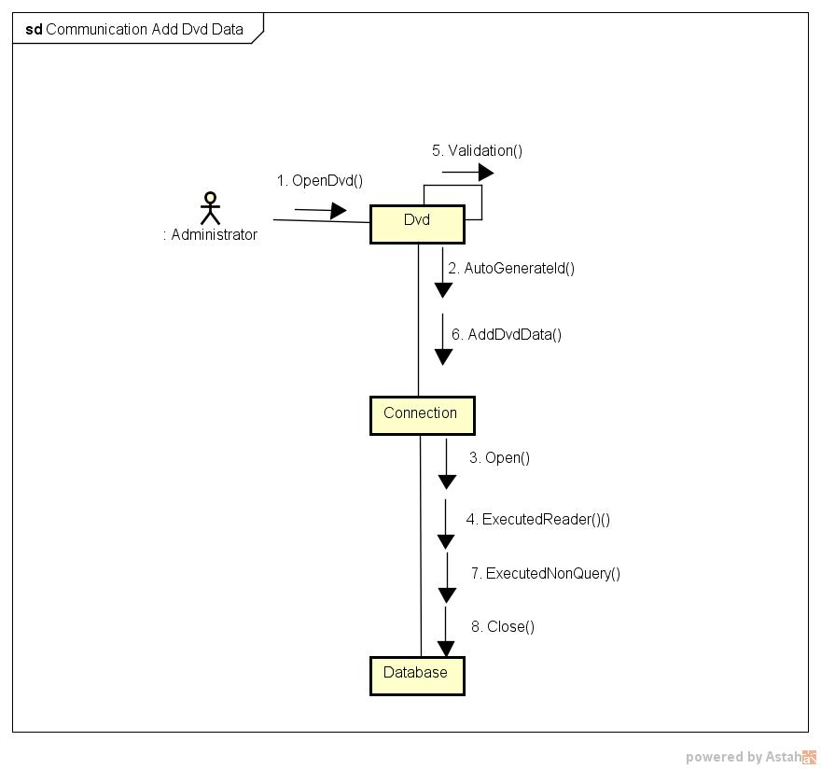

**COMMUNICATION DIAGRAM FOR UPDATE DVD DATA**

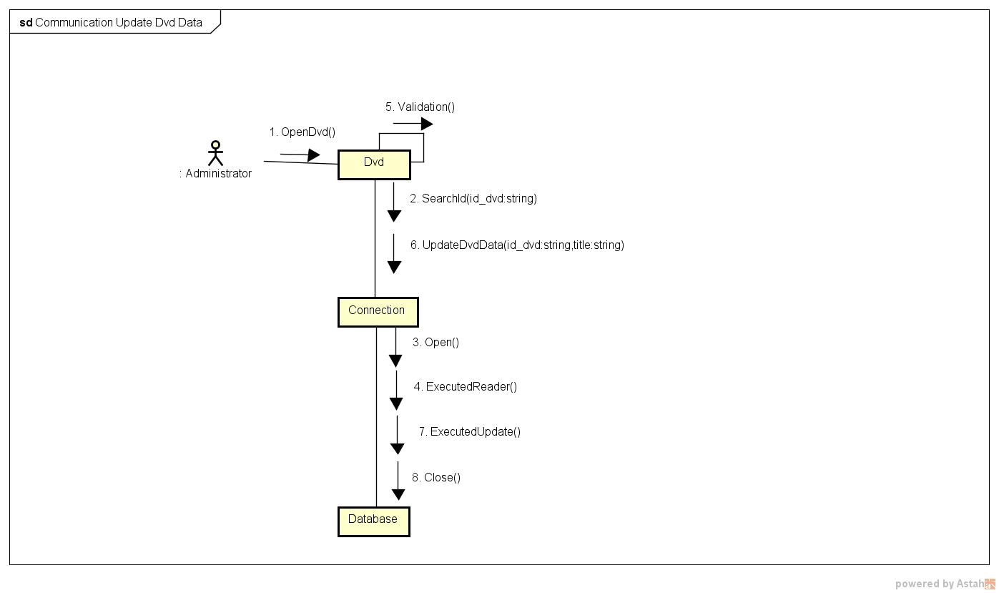

**COMMUNICATION DIAGRAM FOR DELETE DVD DATA**

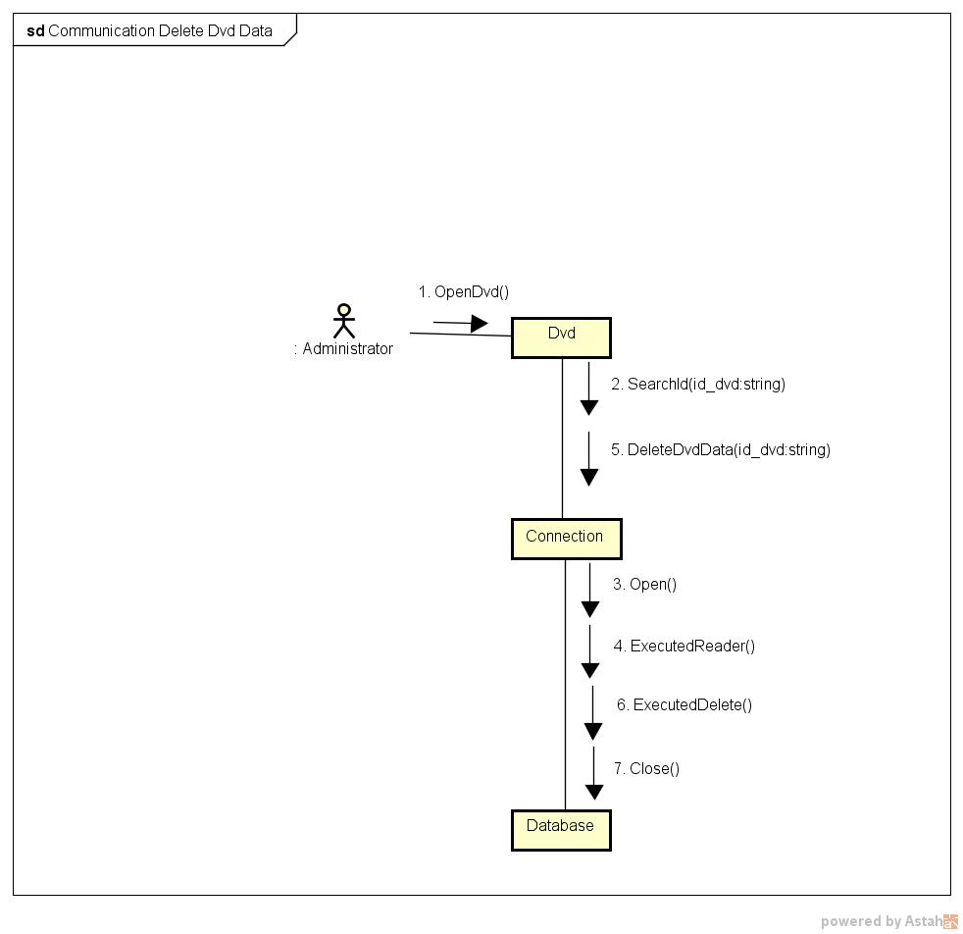

**COMMUNICATION DIAGRAM FOR ADD EMPLOYEE DATA**

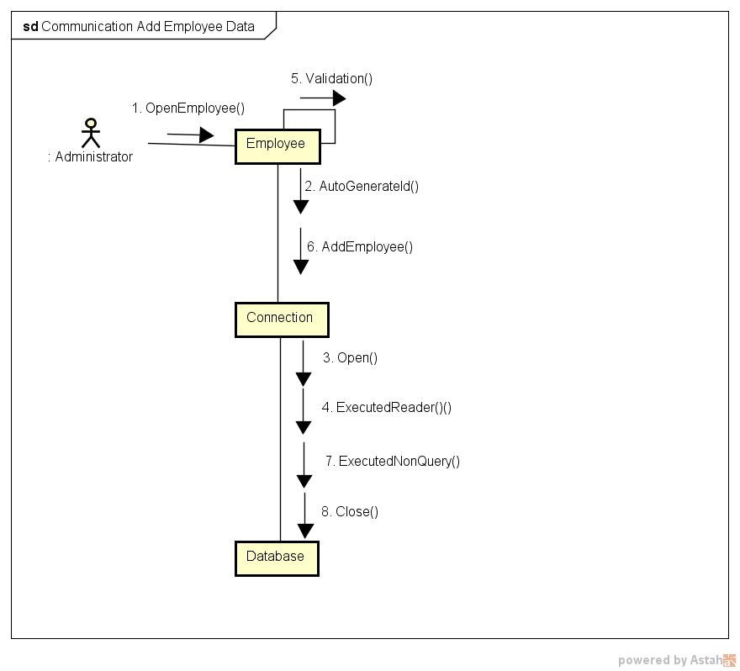

**COMMUNICATION DIAGRAM FOR UPDATE EMPLOYEE DATA**

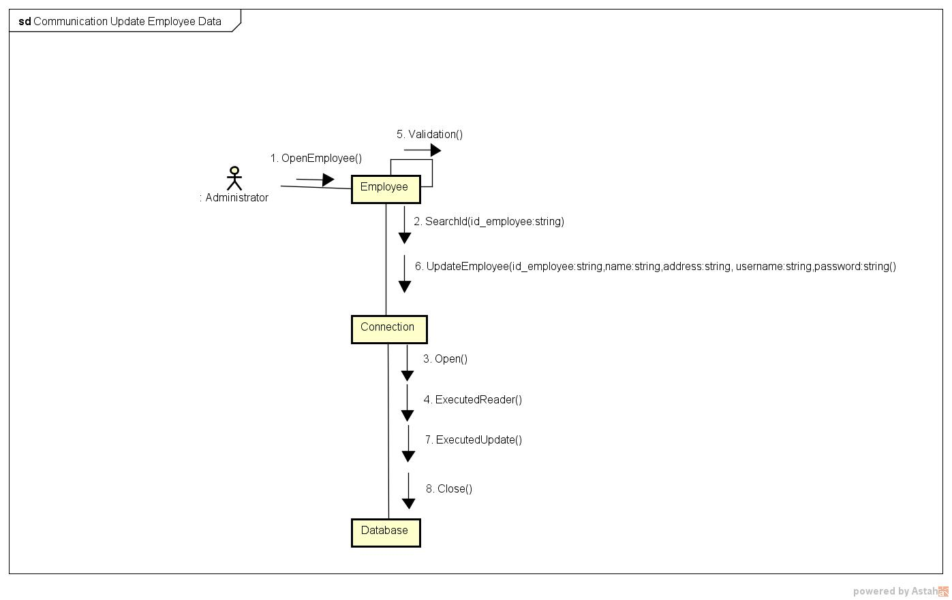

**COMMUNICATION DIAGRAM FOR DELETE EMPLOYEE DATA**

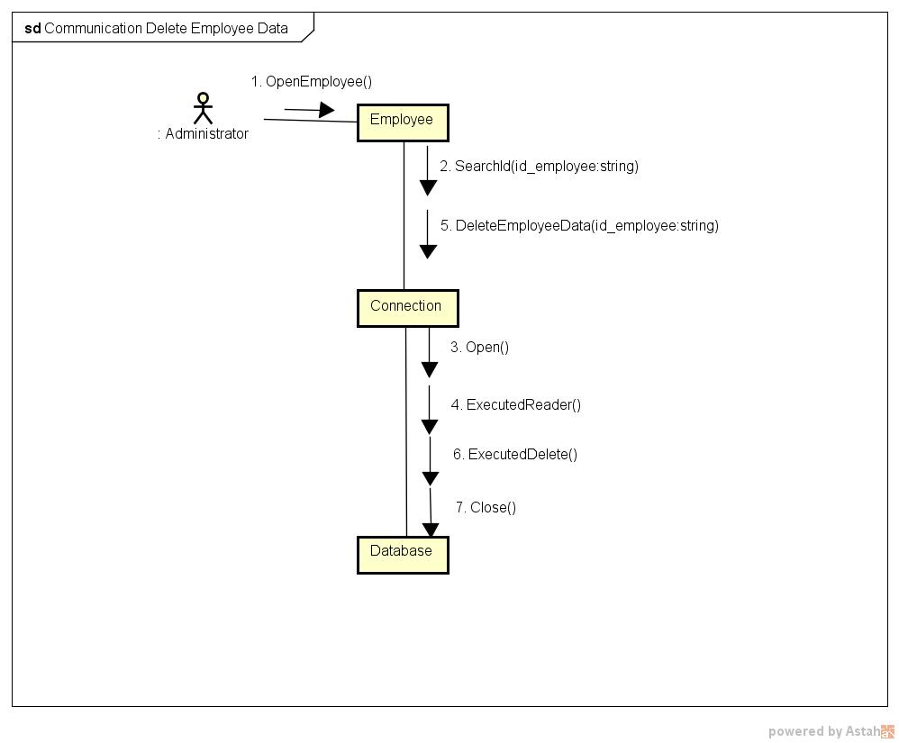

**STATE CHART DIAGRAM FOR LOGIN**

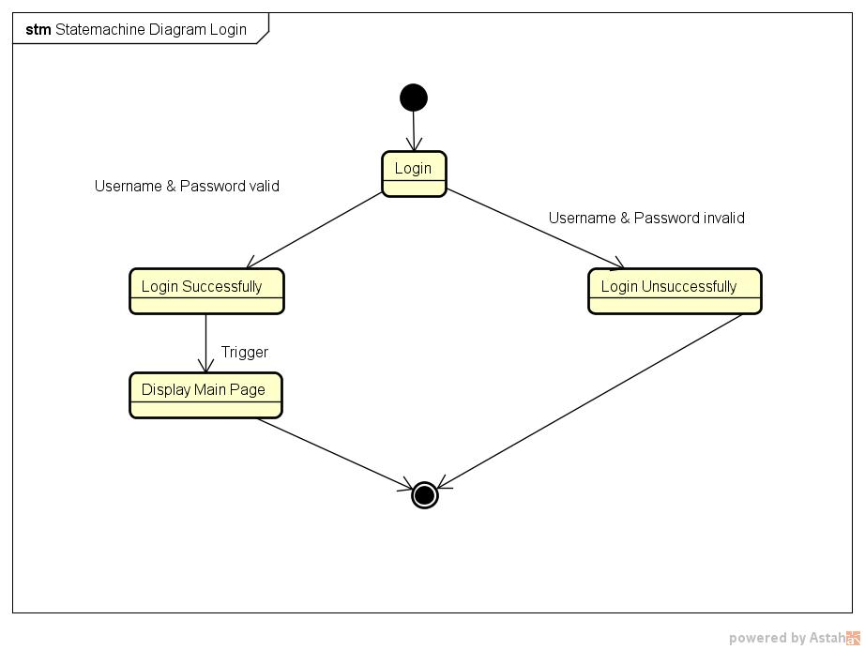

**STATE CHART DIAGRAM FOR REGISTRATION**

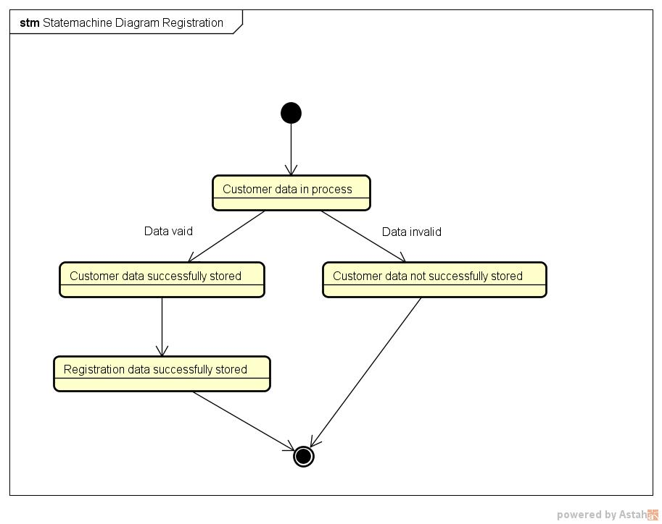

**STATE CHART DIAGRAM FOR ORDER DVD**

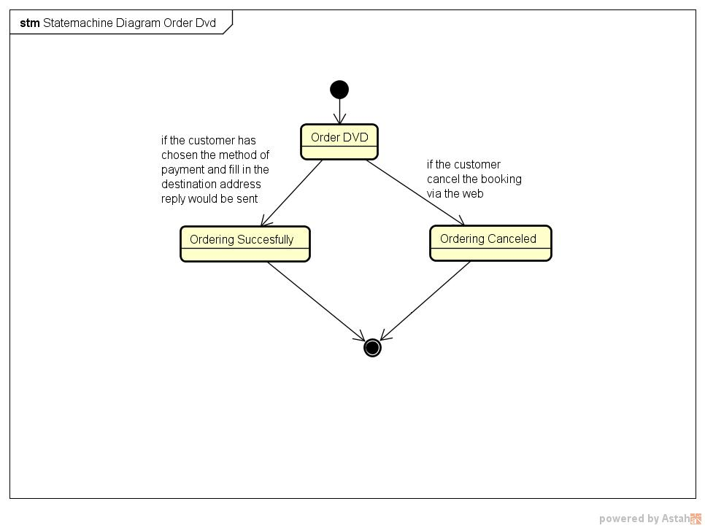

**STATE CHART DIAGRAM FOR AVAILABILITY DVD**

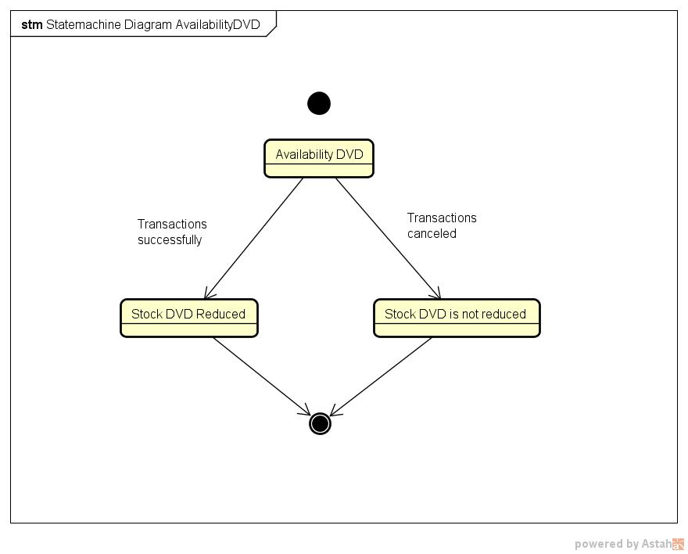

**STATE CHART DIAGRAM FOR SEARCH DVD DATA**

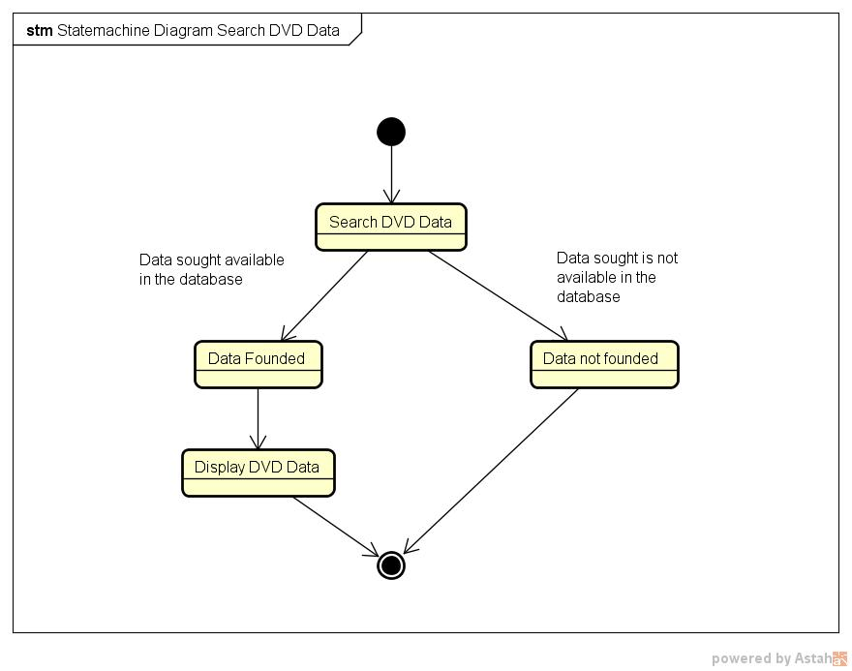

**STATE CHART DIAGRAM FOR CHANGE ORDER STATUS**

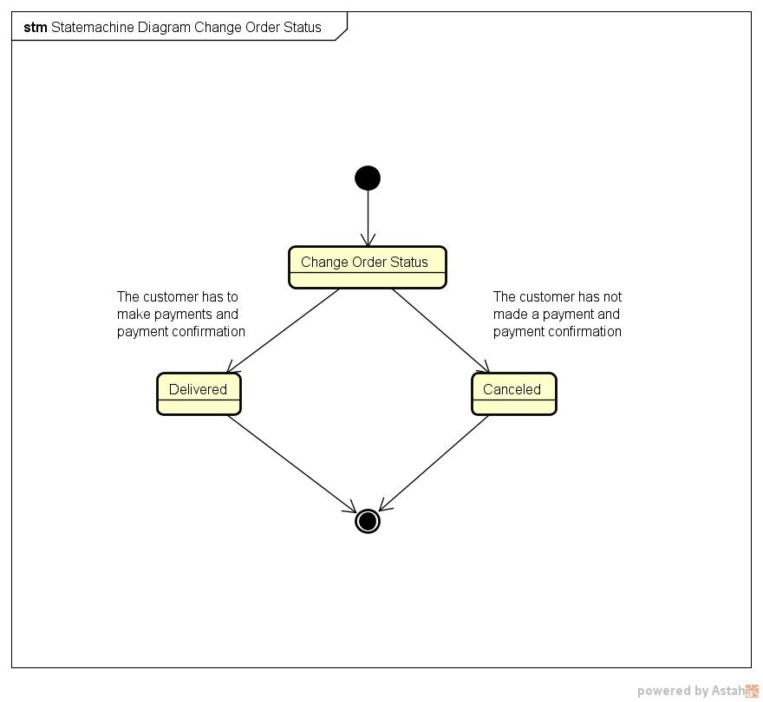

**ACTIVITY DIAGRAM FOR REGISTRATION**

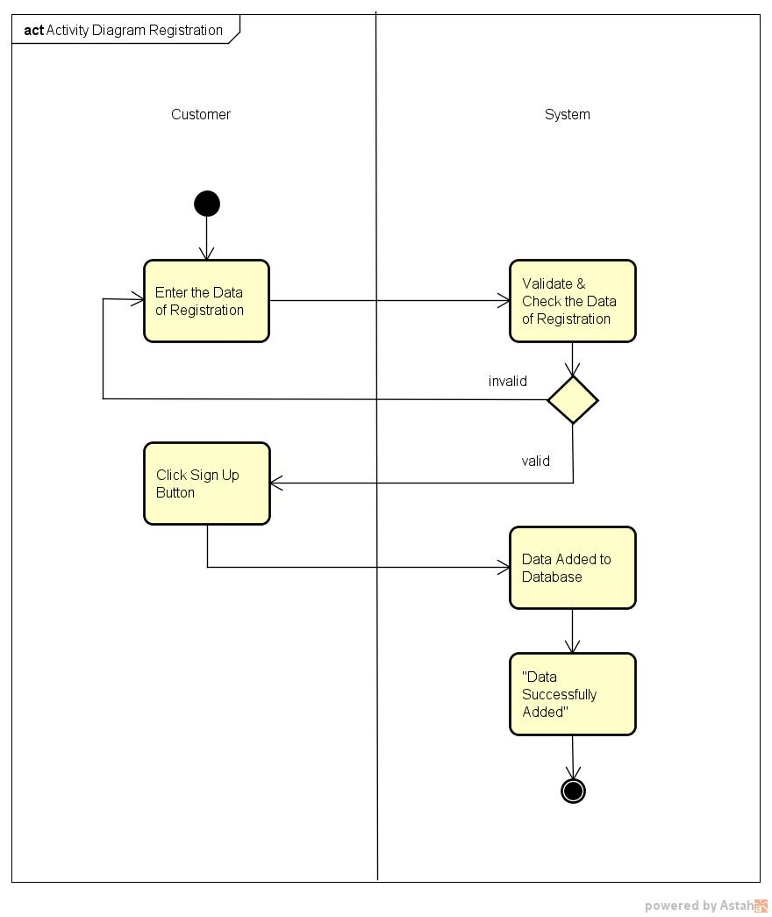

**ACTIVITY DIAGRAM FOR LOGIN**

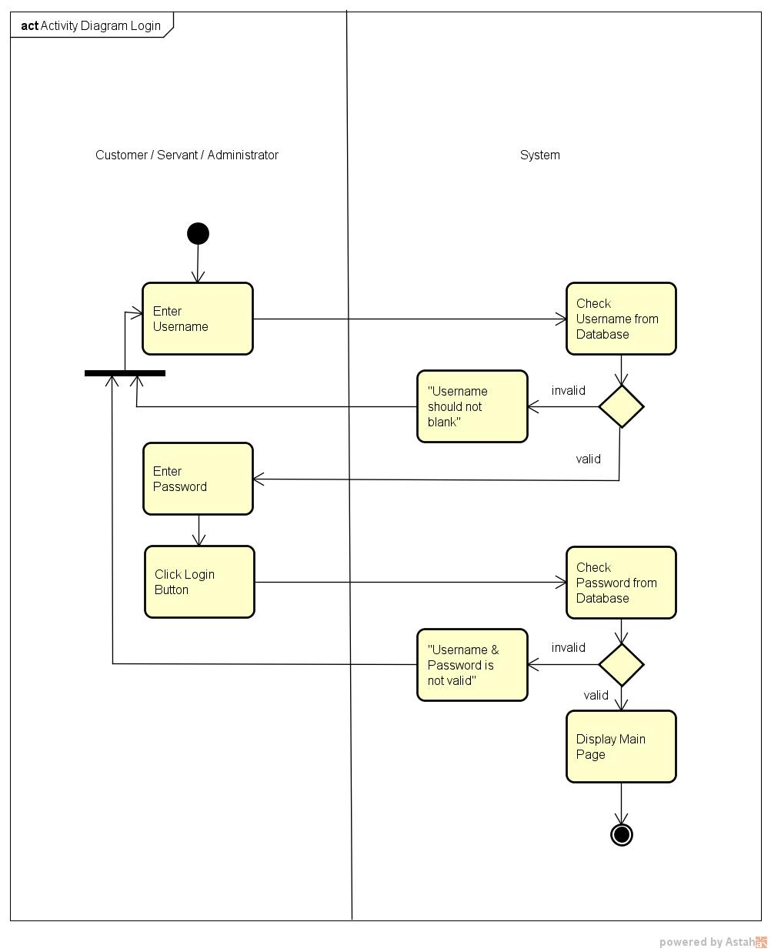

**ACTIVITY DIAGRAM FOR ORDER DVD**

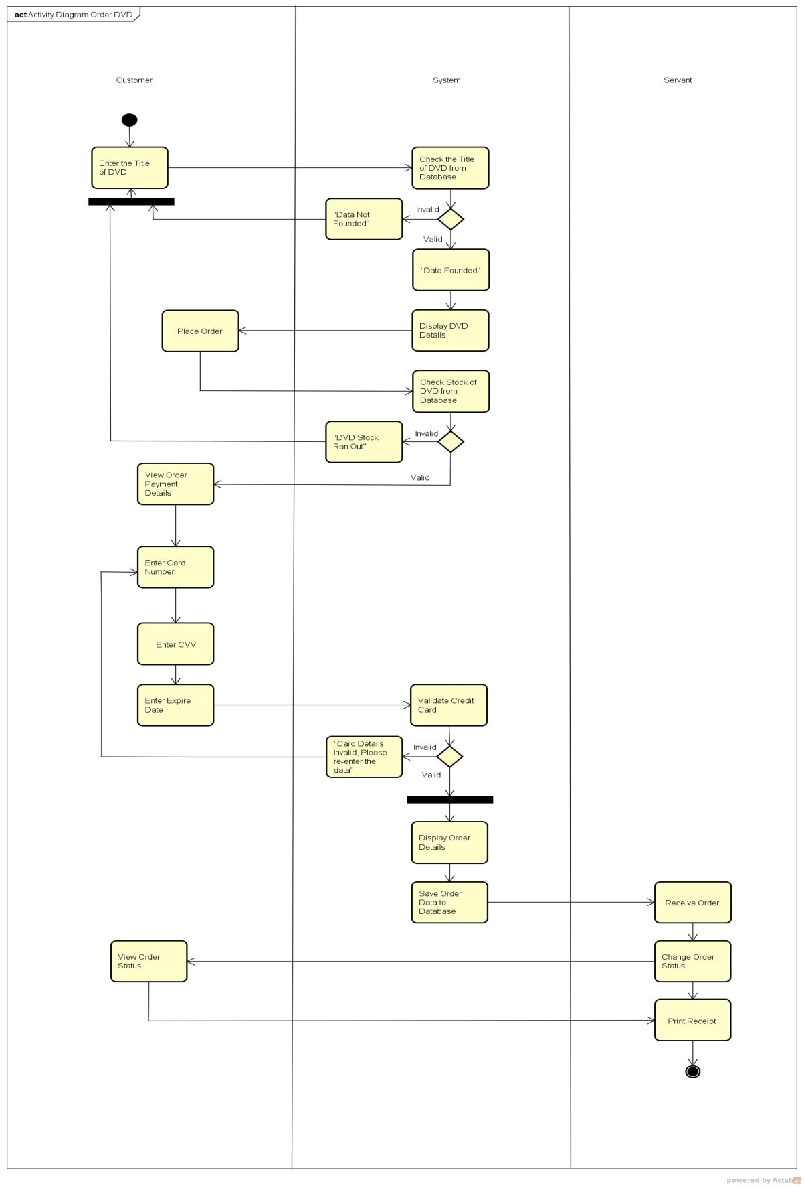

**ACTIVITY DIAGRAM FOR VIEW ORDER**

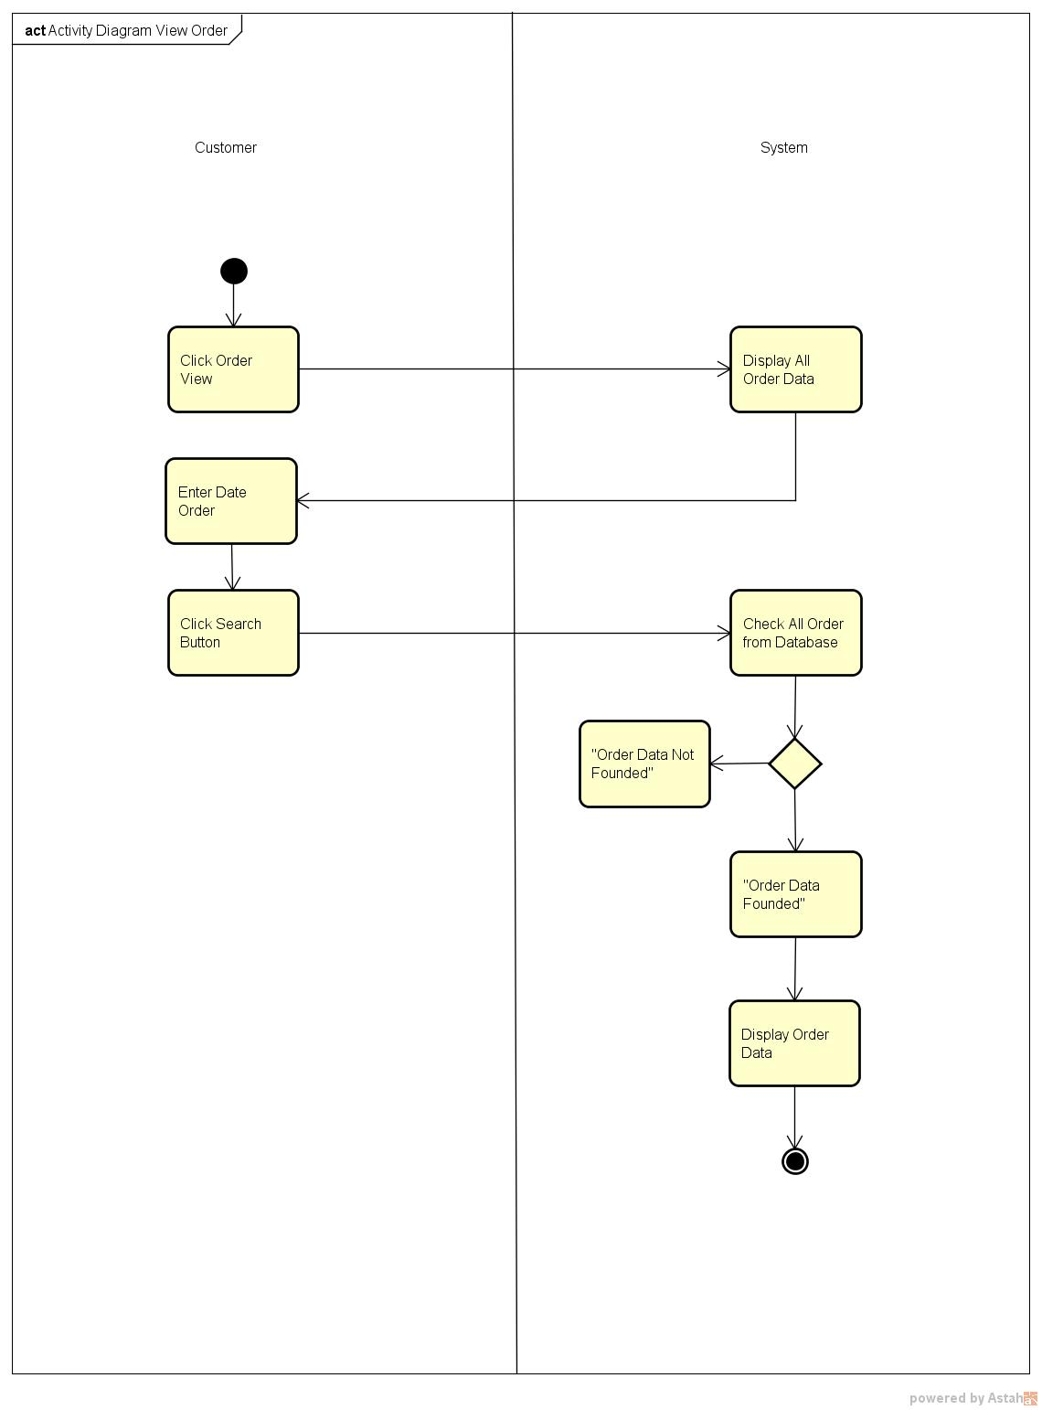

A**CTIVITY DIAGRAM FOR MODIFY PERSONAL INFO**

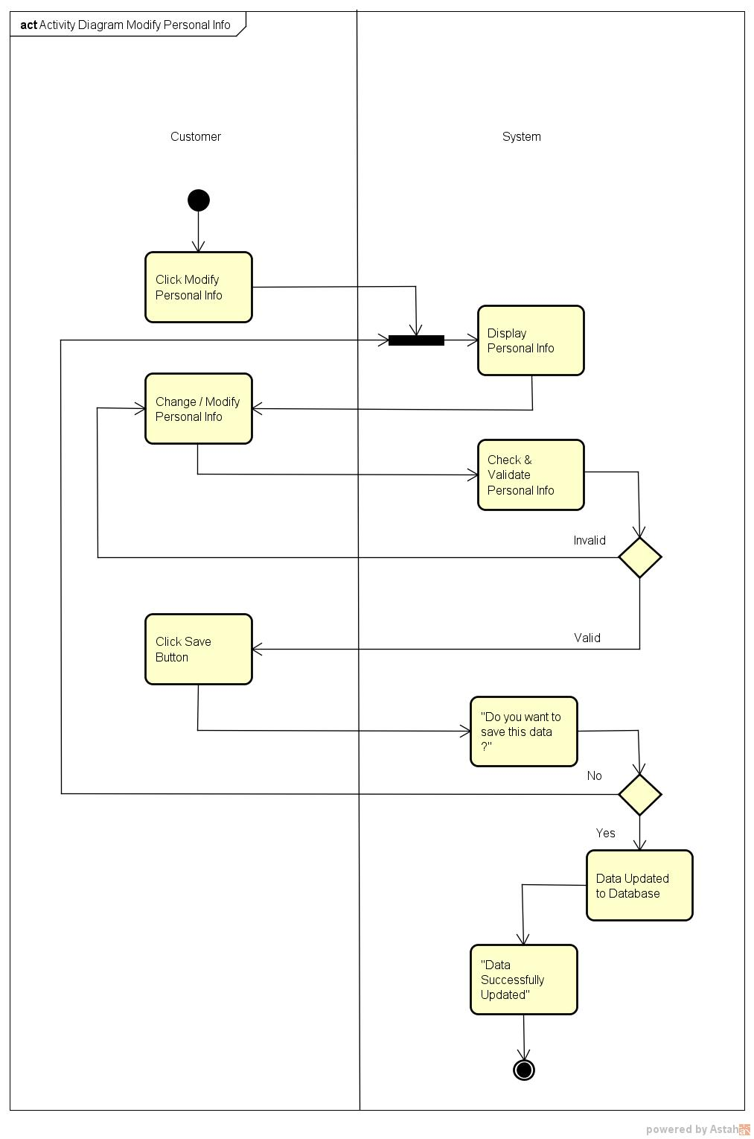

**ACTIVITY DIAGRAM FOR VIEW CUSTOMER DATA**

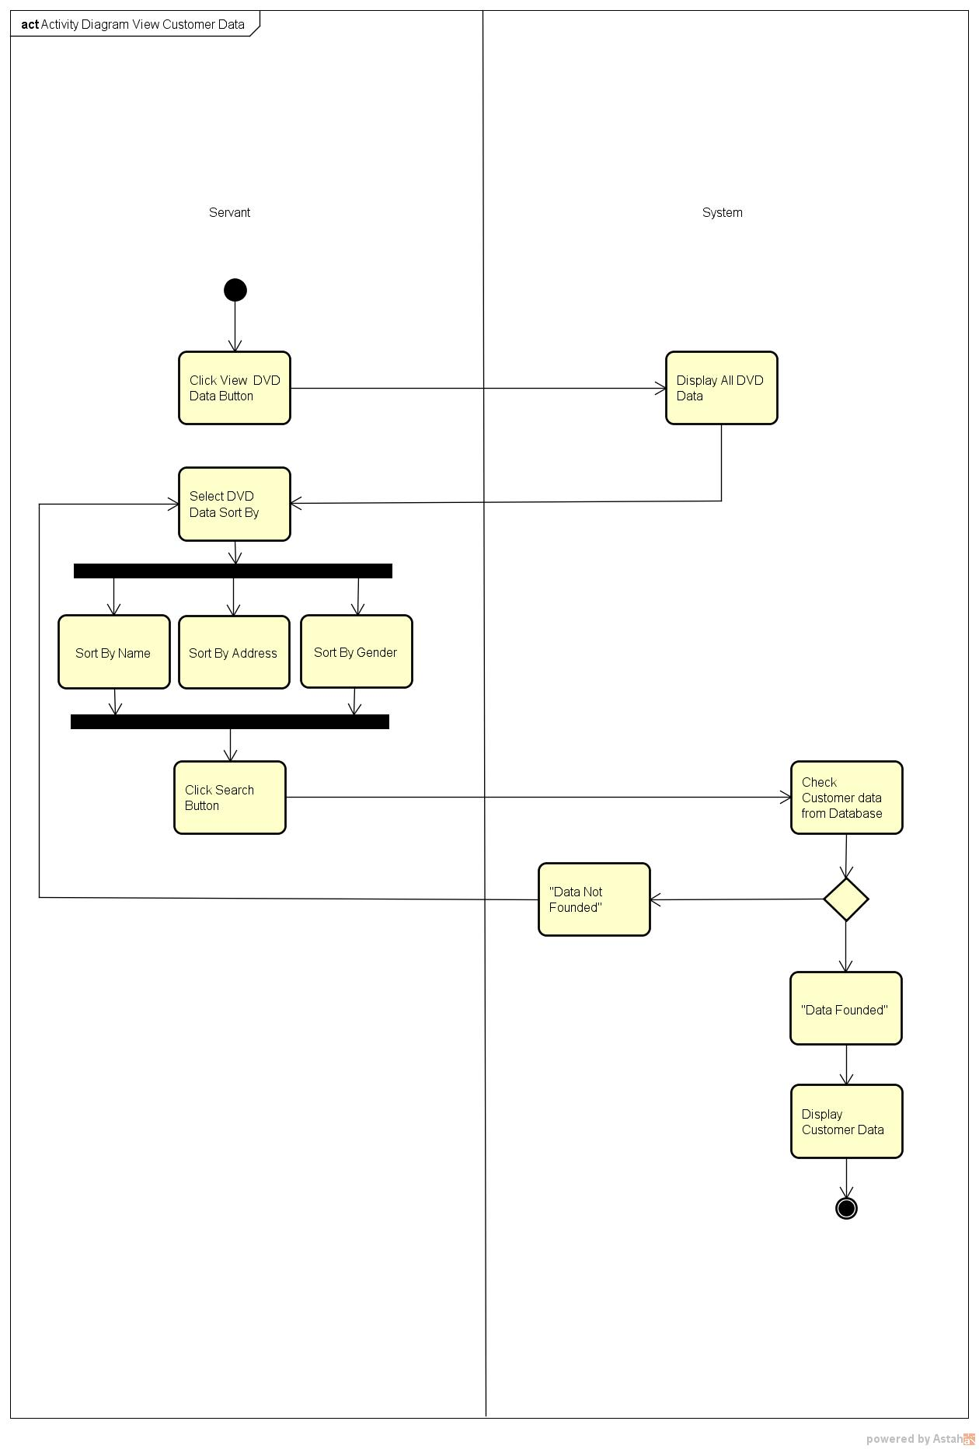

**ACTIVITY DIAGRAM FOR VIEW DVD DATA**

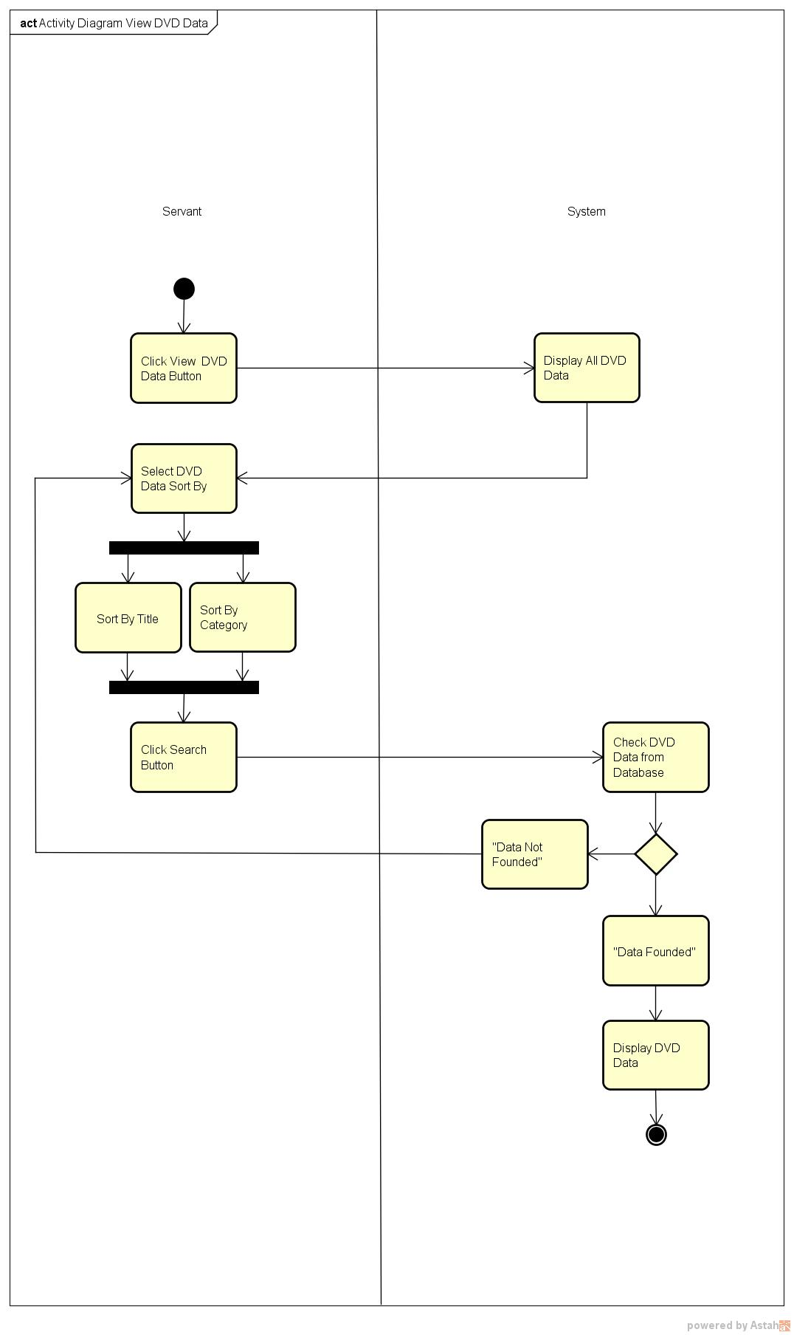

**ACTIVITY DIAGRAM FOR PRINT RECEIPT**

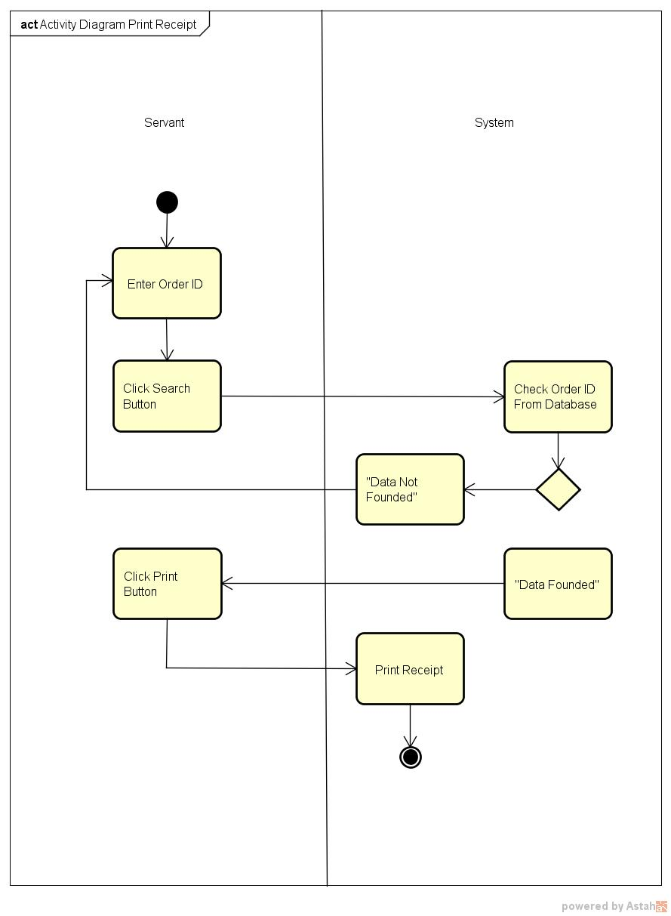

**ACTIVITY DIAGRAM FOR SEARCH EMPLOYEE DATA**

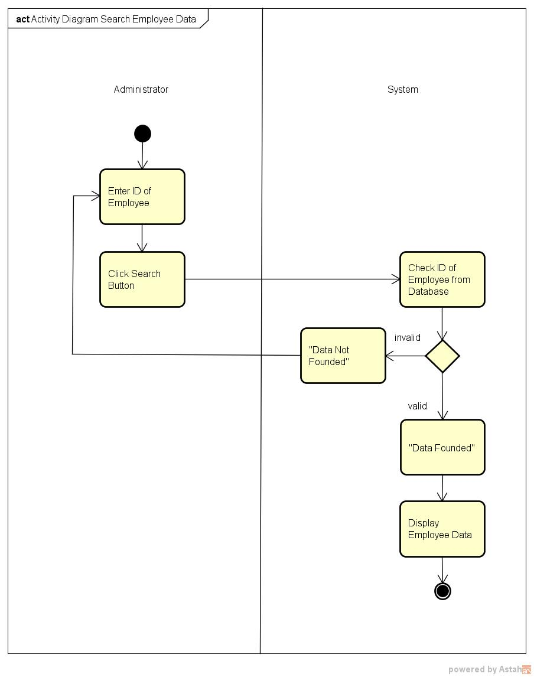

**ACTIVITY DIAGRAM FOR ADD EMPLOYEE DATA**

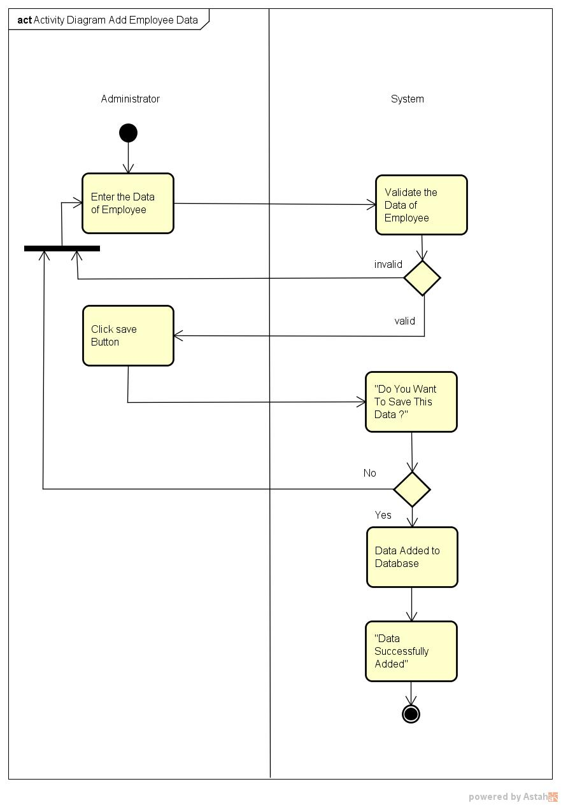

**ACTIVITY DIAGRAM FOR UPDATED EMPLOYEE DATA**

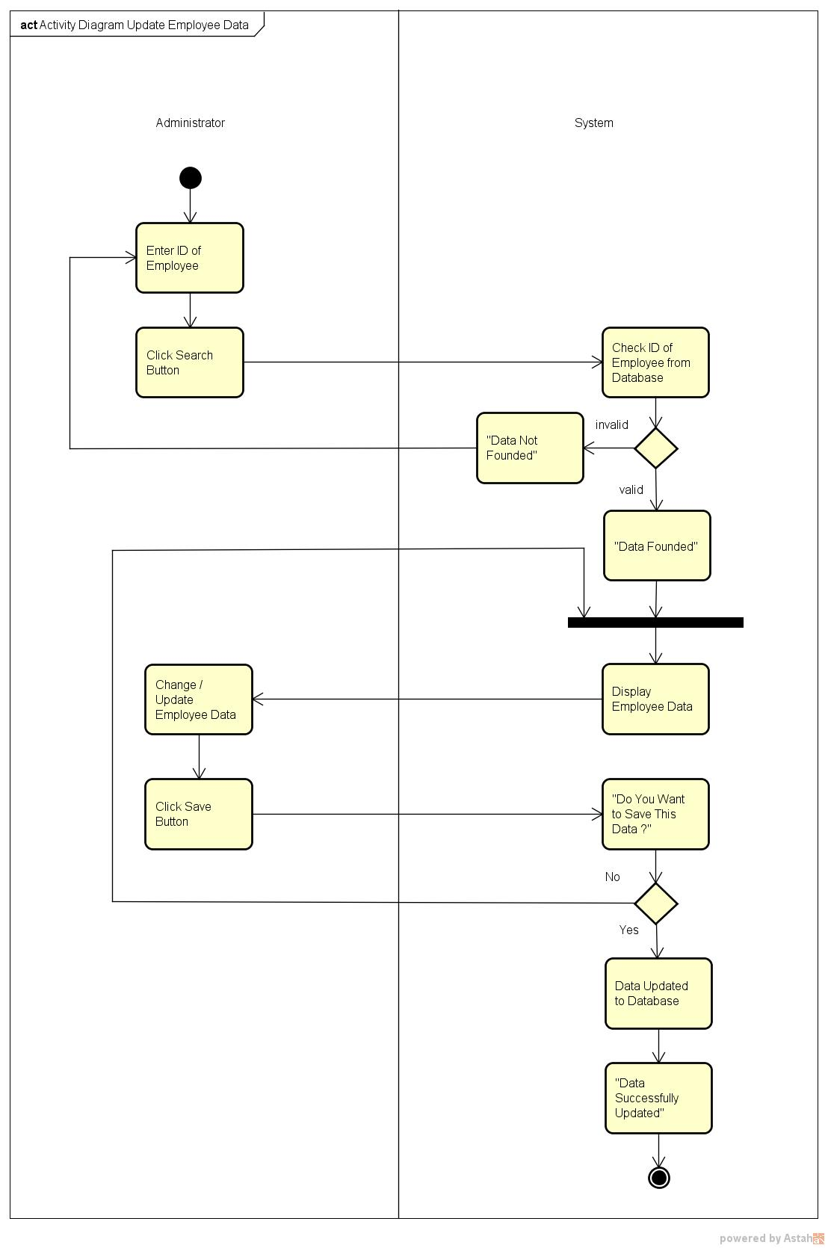

**ACTIVITY DIAGRAM FOR DELETE EMPLOYEE DATA**

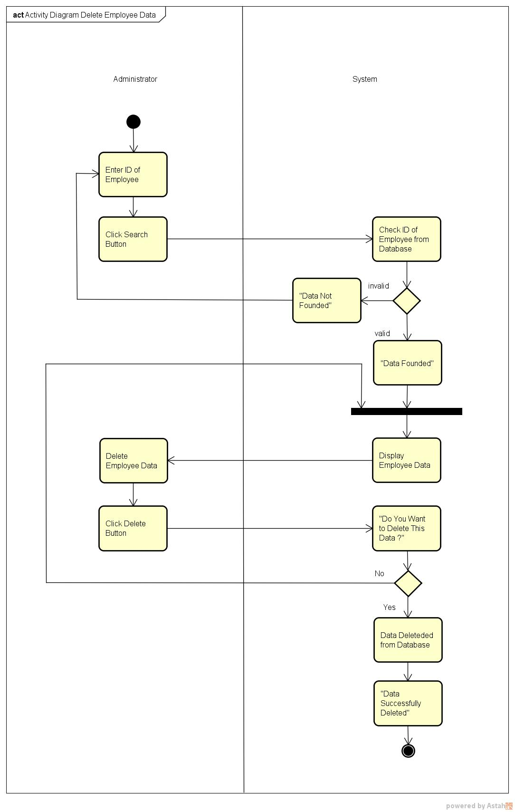

**ACTIVITY DIAGRAM FOR ADD DVD DATA**

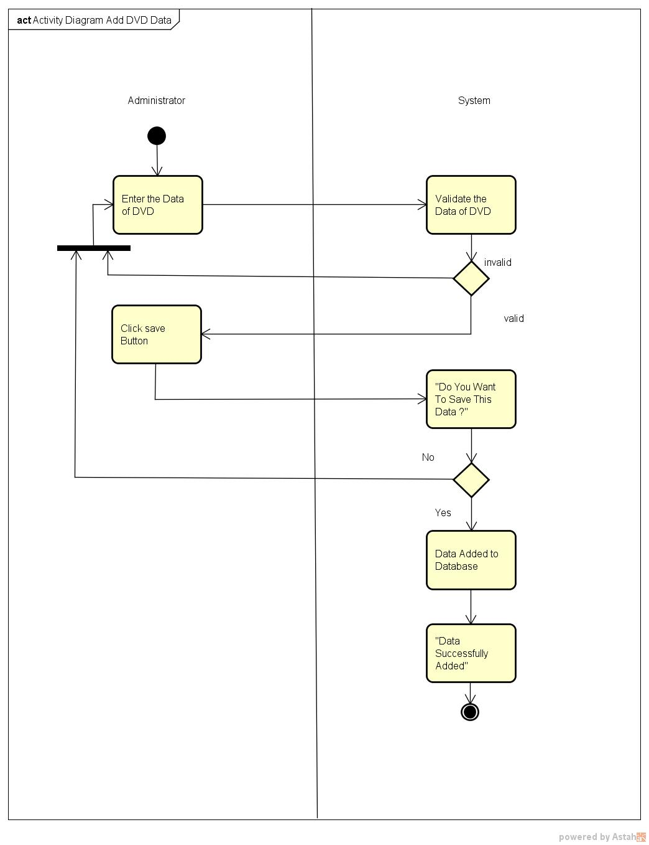

**ACTIVITY DIAGRAM FOR UPDATE DVD DATA**

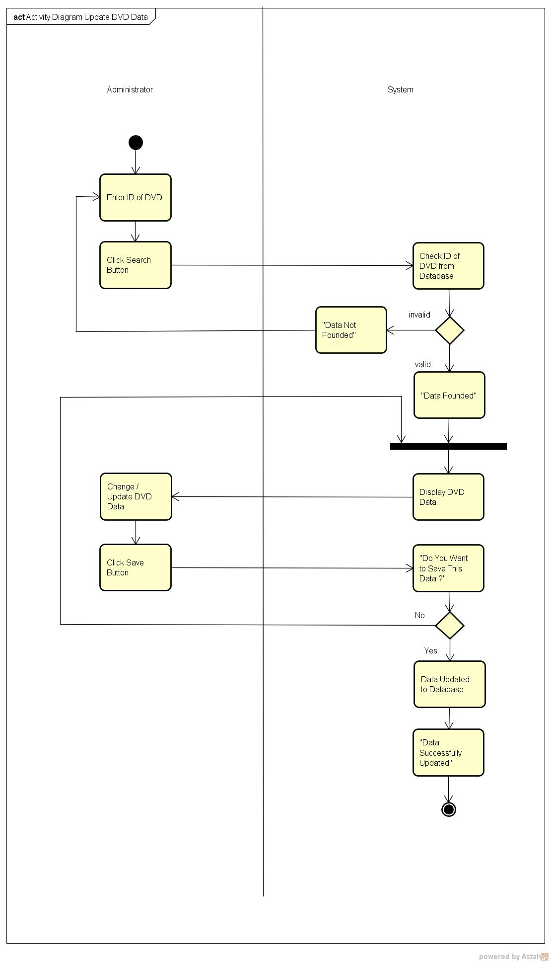

**ACTIVITY DIAGRAM FOR DELETE DVD DATA**

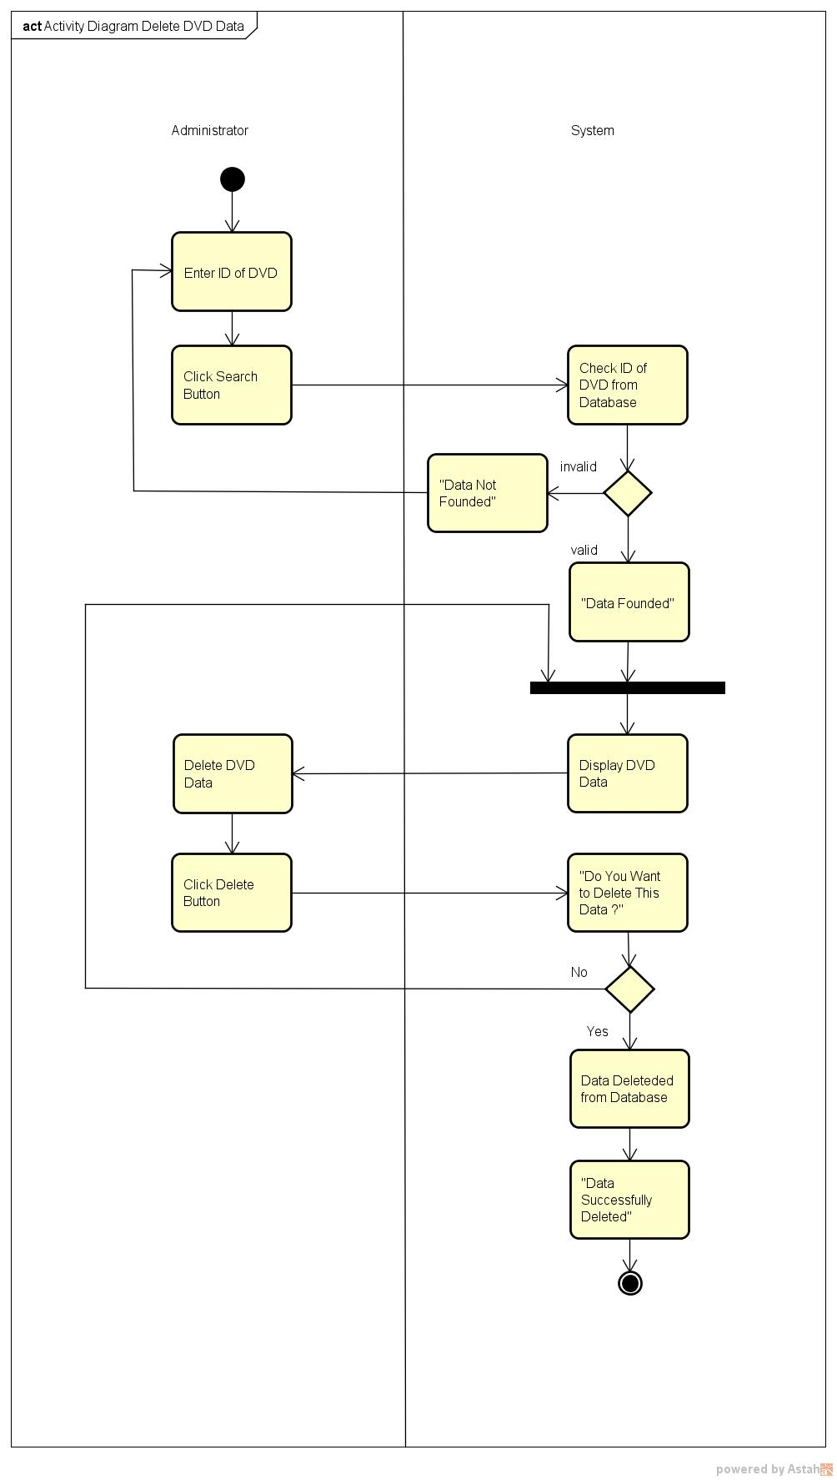

**ACTIVITY DIAGRAM FOR MONITORING CUSTOMER ORDER**

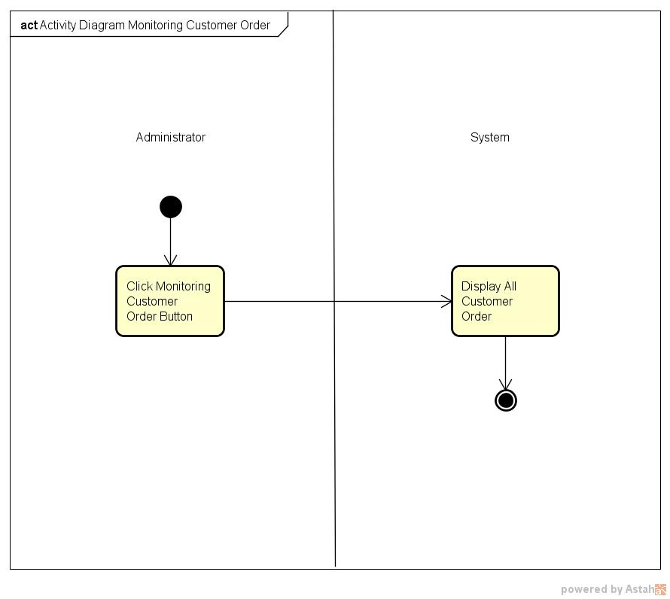

**ACTIVITY DIAGRAM FOR MONITORING CUSTOMER DATA**

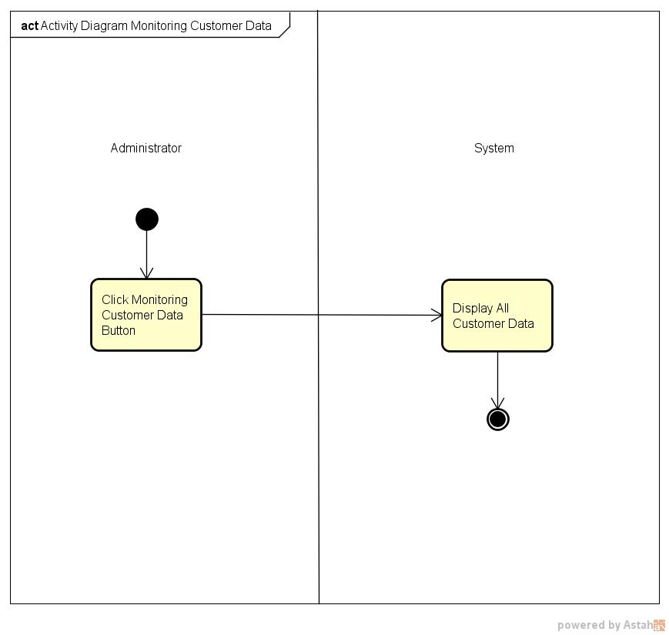

**ACTIVITY DIAGRAM FOR PRINT CUSTOMER REPORT**

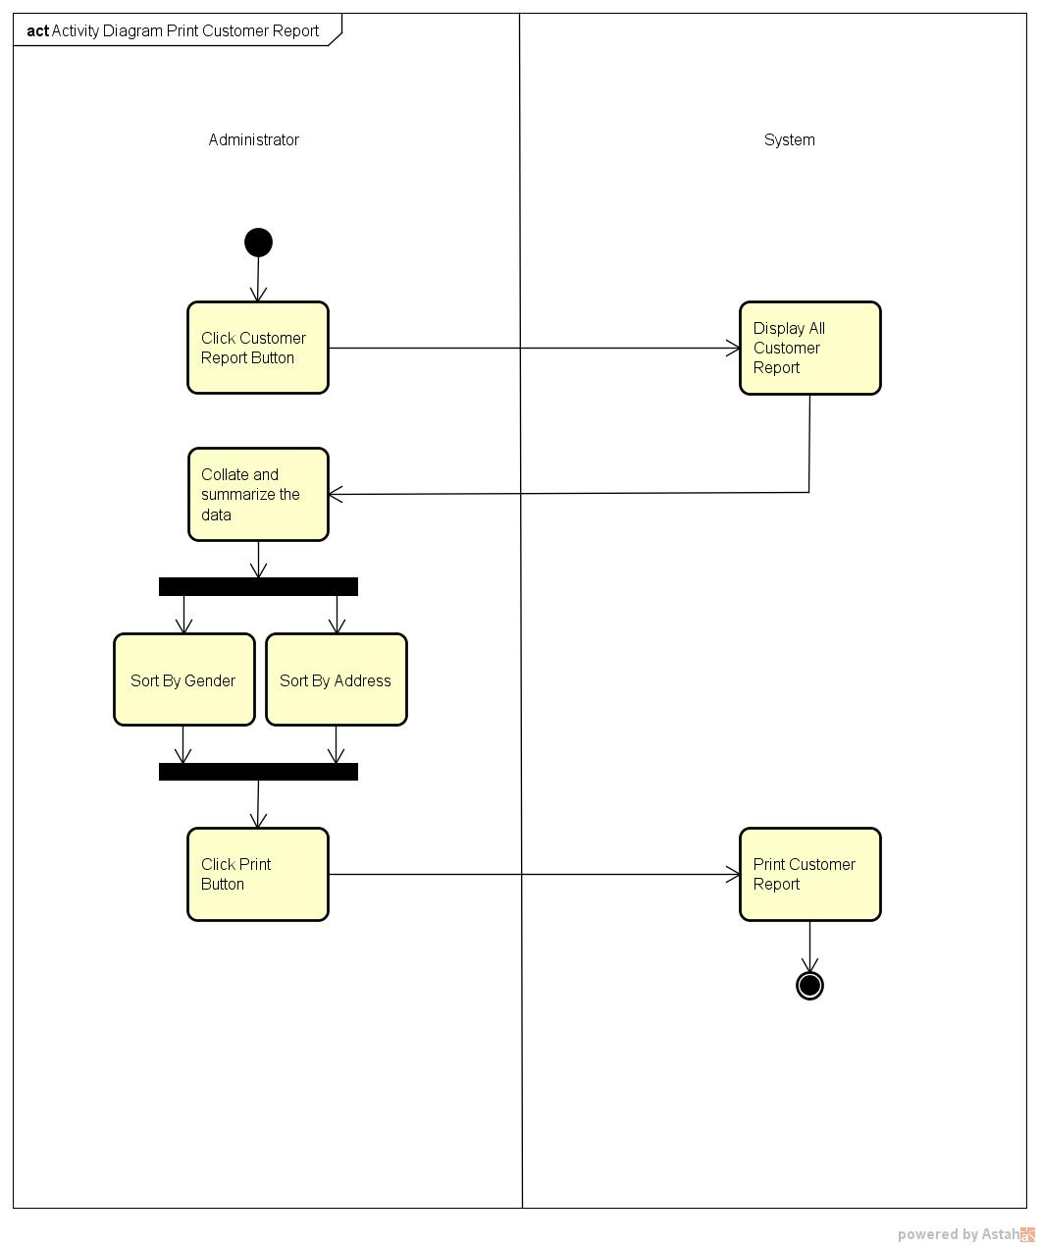

**ACTIVITY DIAGRAM FOR PRINT EMPLOYEE REPORT**

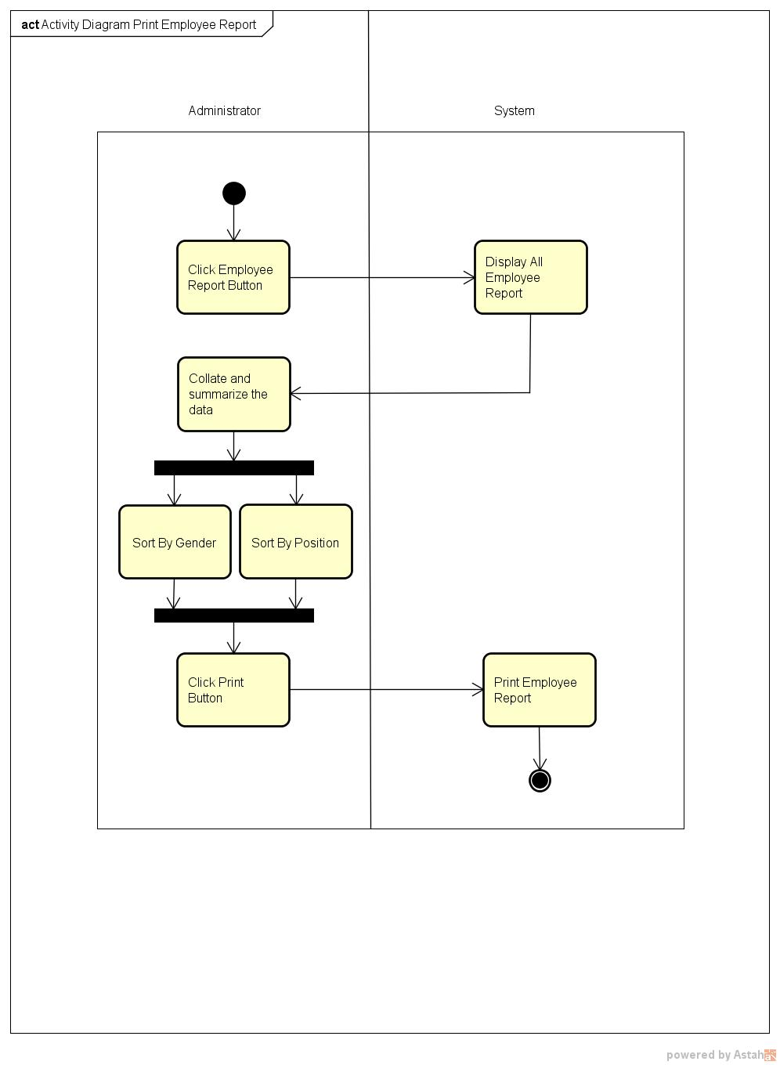

**ACTIVITY DIAGRAM FOR PRINT ORDER REPORT**

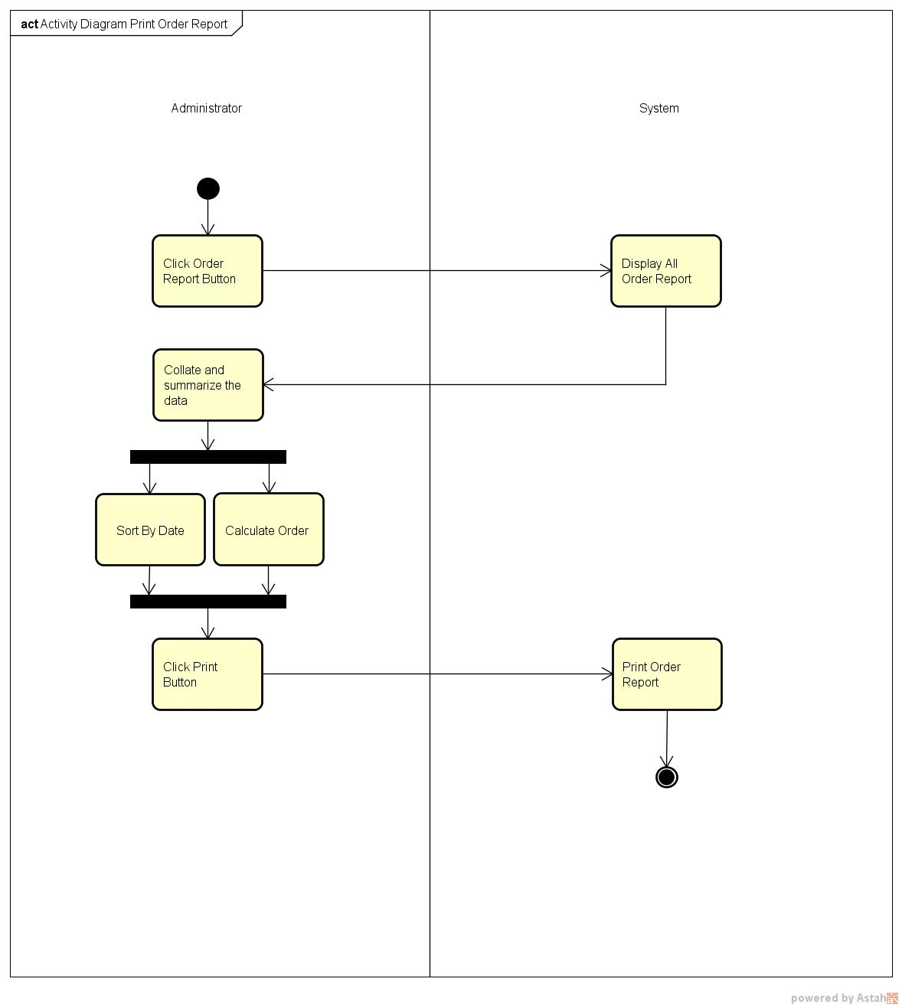

**OBJECT DIAGRAM**

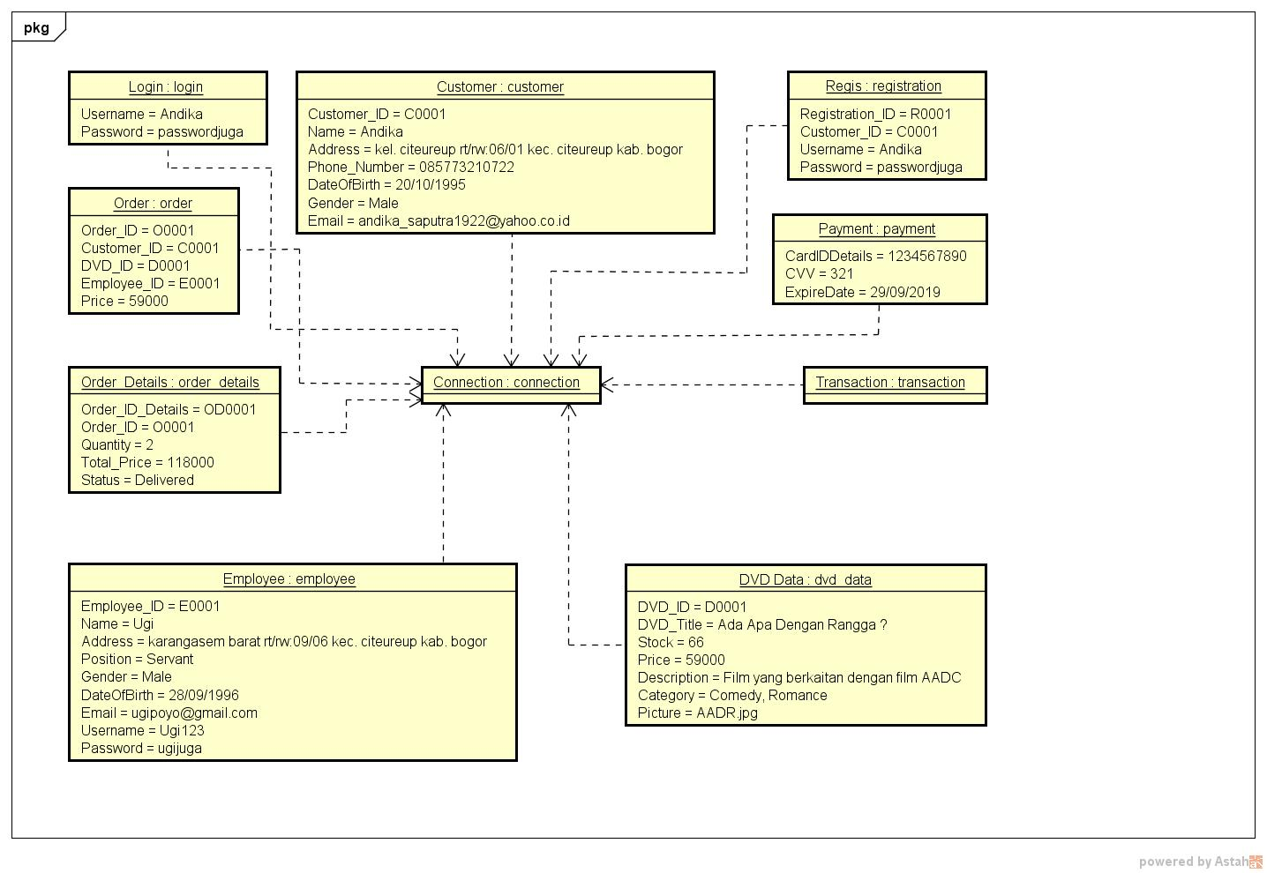

**PACKAGE DIAGRAM**

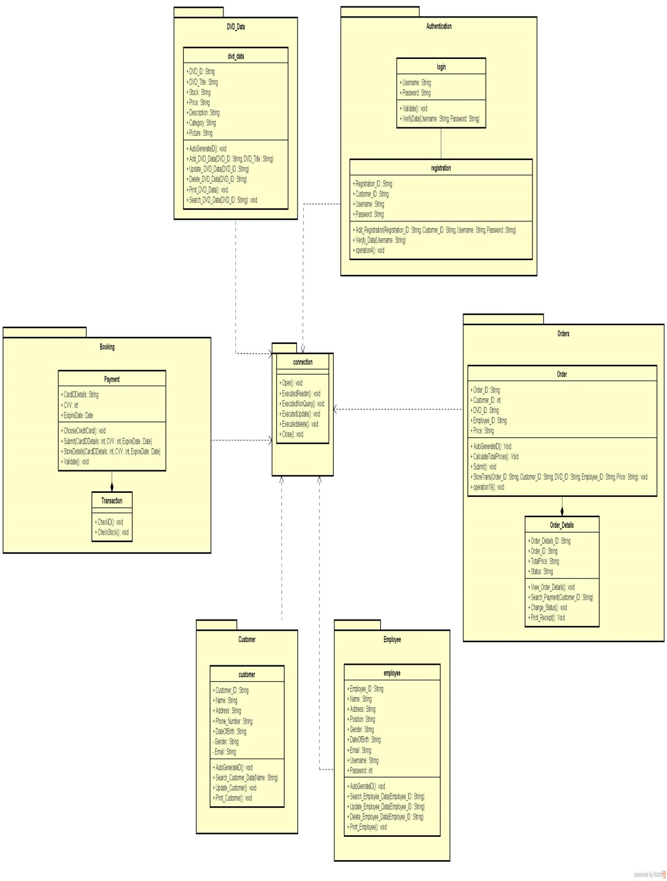

**COMPONENT DIAGRAM**

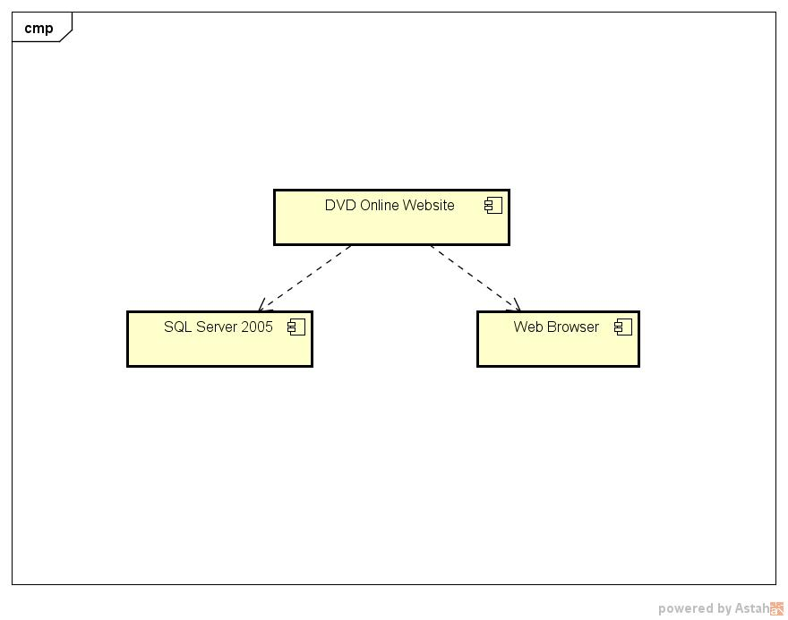

**DEPLOYMENT DIAGRAM**

